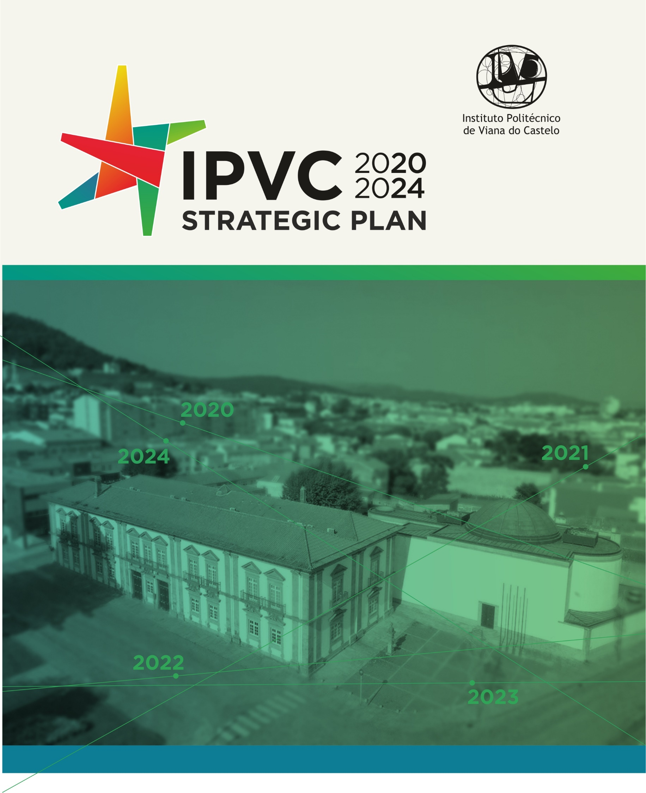
05/02/2020
Document approved by the IPVC’s General Council
Edited by the IPVC
Developed by the Technical Commission of the IPVC’s 20-24 Strategic Plan
Design and paging by GCI-IPVC

Table of Contents

1. Framework 3
2. The Reality of the IPVC 5
3. SWOT Analysis 34
4. IPVC Strategy 38
Purpose 38
Mission 38
Vision 38
Values 39
Management Policy 40
Social Responsibility Aspects of the IPVC 41
5. Strategic Axes 42
Management structures 44
Training 45
Students 46
Human Resources 47
R&D 48
Internationalisation 49
Provision of services and development of innovation projects 50
Financial sustainability 51
A Sustainable and inclusive Campus 52
AXIS INTERACTION MATRIX with STRATEGIC PROJECTS and INITIATIVES 71
AXIS INTERACTION MATRIX with INDICATORS for AXIS performance evaluation 81
List of Acronyms 85
List of Tables 86
List of Figures 87

1. Framework

In order to carry out a detailed analysis of the current reality of the Polytechnic Institute of Viana do Castelo (IPVC) as well as to define strategic guidelines, projects and initiatives aimed at their development under optimal conditions, the Presidency of the Polytechnic promoted the drafting of the Strategic Plan of the Polytechnic Institute of Viana do Castelo for 2020-2024.
Among others, this work aimed at the following objectives:
- Carry out a detailed diagnosis of the current context of the IPVC;
- Define a developmental strategy for the IPVC including the identification of objectives and targets to be achieved;
- Develop a plan of action for the IPVC;
- Elaborate the Strategic Plan for the IPVC 2020-2024.
In order to achieve these objectives, a methodology was defined, composed of different activities:
- Analysis of the current IPVC context;
- Defining the IPVC development strategy;
- Drafting of the IPVC's Plan of action;
- Drafting of the IPVC's Strategic Plan for 2020-2024.
A strategic design was purported in a shared way and with the involvement of the main recipients and key players for its achievement. In this sense, meetings were held with members of government agencies and IPVC services (namely with the President of the General Council), with school principals and deputy directors, with course coordinators and with students' association leaders. Meetings were also held with several institutions and companies in the Region.
Within this framework, different documents relating to the IPVC were reviewed, where the following stand out: the diploma establishing the IPVC, the statutes of the IPVC and the different Schools, the IPVC's Strategic Plan for 2015-2019, the current President of the IPVC's Plan of Action, the Activities and Accounts Report for 2018 and the Activities Plan for 2019, the Management Manual - Quality and Social Responsibility and the final Report by CAE relating to Institutional Evaluation of the IPVC.
Regarding external documents, we highlight the following: data and statistics from the General Directorate of Statistics for Education and Science (DGEEC), final results of the evaluation of the 2017/2018 R&D units of the Foundation for Science and Technology, data from articles published in scientific journals of Web of Science between 2017 and 2019 and an ANI study on Polytechnic Institutes in Research and Development (R&D) and Innovation projects.
Data was also gathered from the IPVC services on different aspects of the Polytechnic's activity, namely: support services, human resources, training, students, R&D, service provision and internationalization.
In addition, with the aim of listening to stakeholders regarding the present and future challenges of the IPVC, 5 workshops were held with focus on the following topics:
- Internationalization;
- Research, Development and Innovation;
- Cooperation with the community;
- Pedagogical innovation;
- Organizational management.
These workshops were attended by more than 100 key Polytechnic players and stakeholders from the Region (Table 1).

Table 1. Workshops held
Field | Guest Speaker | N. of participants |  | Date
 |  | Internal | External
Internationalization | Víctor Vázquez (Vice-Rector of the University of Santiago de Compostela for the sectors of Students and Internationalization) | 17 | 1 | 15/01/2019
Research, Development & Innovation | José Manuel Mendonça (Chairman of the Board of Directors of INESC TEC) | 19 | 5 | 21/01/2019
Cooperation with the community | Bárbara Gabriel (Deputy Director for Internationalization and Cooperation in the Mechanical Engineering Department of the University of Aveiro) | 11 | 9 | 21/01/2019
Pedagogical Innovation | João Costa (Dean of Pedagogical Innovation and Student Affairs at the University of Minho) | 20 | 1 | 22/01/2019
Organizational management | Raquel Velada (Coordinator of the ISCTE Planning, Sustainability and Quality Office) | 20 | 0 | 22/01/2019

2. The Reality of the IPVC

The evolution of the above-mentioned activities allowed for a portrayal of the reality of the IPVC when taking into consideration nine domains of particular relevance: Management Structures, Training, Students, Human Resources, R&D, Provision of services and Development of innovation projects, Internationalization, Financial Sustainability and A Sustainable and Inclusive Campus (Figure 1).

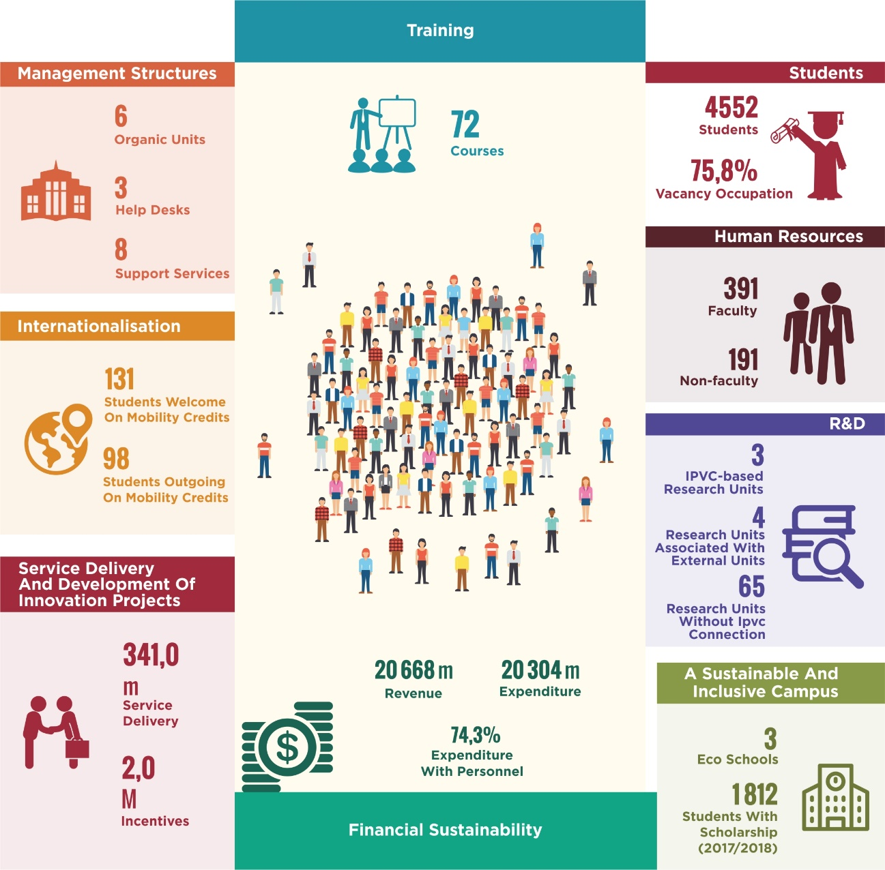
Figura 1. Main IPVC indicators (SAS not included)
The information presented has as reference: management structures, training, students and human resources - academic year 2019/2020; R&D, service delivery and financial sustainability - 2018; development of innovation projects - period 2016 to 2018; internationalization - academic year 2018/2019; sustainable and inclusive campus - academic year 2017/2018.
MANAGEMENT STRUCTURES
The IPVC is made up of six organic units, three functional units, eight services and three support offices (Figure 2).
Academic Federation
Estudent Association
Academic Council
Student Ombusman
Management Council
Funcional Units
Social Services;
OTIC (to initiate);
Library (to initiate)
Scientific-Technical Council
Scientific Areas
Disciplinary Groups
Services
Directorate for Strategic Planning and Development (to initiate);
Directorate for Administrative and Financial Services;
Directorate for IT Services;
Technical Services Division;
Academic Services Division;
Human Resources Division;
Dispatches and Archive Services
Assessment and Quality Department;
Legal department (to initiate);
Mobility and International Cooperation Department;
Communication and Image Department;
Internal Audit Department (to initiate);
Presidency Secretariat.
Research Units
Administrator
Schools
Executive Board
Pedagogical Council
Course Coordinator
Front-Desk
Secretarial Support Courses
Executive Board Secretariat
Laboratories
IPVC
General Council
President

Figura 2. IPVC Organization Chart.

The six organic units are the IPVC Schools:
- ESA – Agrarian School (Ponte de Lima);
- ESCE – School of Business Sciences (Valença);
- ESDL – School of Sports and Leisure (Melgaço);
- ESE – School of Education (Viana do Castelo);
- ESS – School of Health (Viana do Castelo); and
- ESTG – School of Technology and Management (Viana do Castelo).
The IPVC comprises seven research units, three of which have the Polytechnic itself as the main managing institution and four are associated to an external institution, as detailed further in this document.
The functional units are as follows:
- Social Services (SAS);
- Library; and
- Technology, Innovation and Knowledge Transfer Unit (OTIC).
For a continuous technical and administrative support of the Polytechnic and its entire organizational structure, the IPVC has a set of Central Services (Figure 3), some of which are complemented by identical services within the Schools.
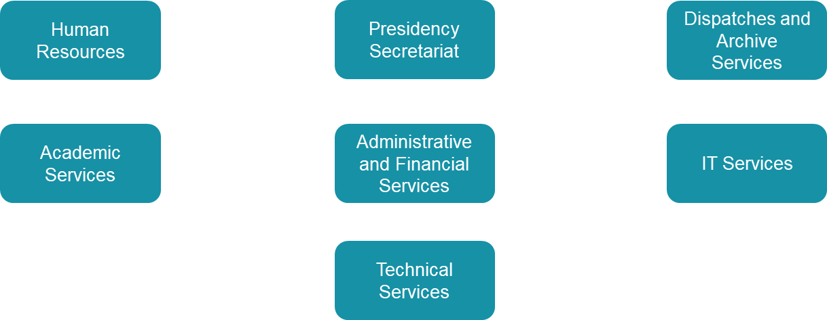
Figura 3. IPVC Central Services.
Source: IPVC, December 2019.

The IPVC also has several offices (Figure 4) that provide assistance to the bodies and services of the Polytechnic.
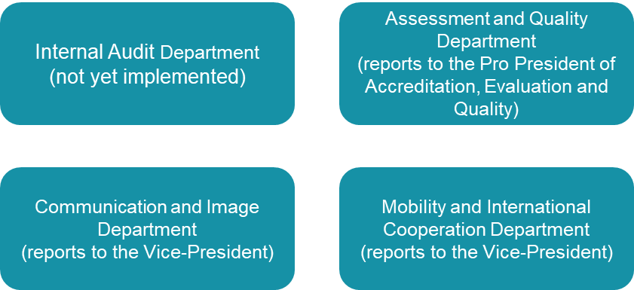
Figura 4. IPVC offices.
Source: IPVC, December 2019

Between 2016 and 2018, the IPVC had 4 projects approved under the Competitiveness and Internationalization Operational Program (COMPETE 2020), all of a transversal nature, aimed at strengthening and modernizing structures (Table 2).
Table 2. Reinforcement projects and modernization of structures.
Project title | IPVC promotor | Value approved IPVC (€) | Year Start | Year End
BeQA@HE (Benchlearning Quality Assurance Systems Higher Education) - UTAD | No | 249.611 | 2018 | 2019
Internationalization Higher Education Portuguese Polytechnic | No | 38.382 | 2016 | 2018
IPVC – Unified Desktop | Yes | 48.486 | 2016 | 2016
SMAC@IPVC&UTAD: Project “Simplification and monitoring of IPVC & UTAD access and communication” | Yes | 493.653 | 2017 | 2019
Source: IPVC, December 2019

TRAINING
With regard to the training offer, in the academic year 2019/2020 the IPVC opened vacancies in 72 courses, between 1st and 2nd cycle courses, postgraduate courses and higher professional technical courses (CTeSP). Figure 5 shows some indicators of the IPVC with regard to training.
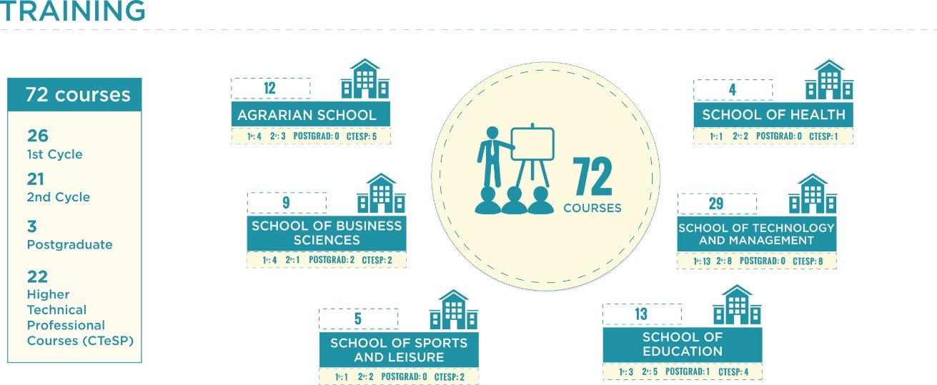
Figure 5. Main IPVC indicators with regard to training.
Note: The information presented has as reference the academic year of 2019/2020

In the current school year, the IPVC's offer at the level of the 1st cycle includes 26 courses (Table 3). The ESTG is the organic unit that offers the largest number of courses (13).
Table 3. 1st cycle courses that opened vacancies in the academic year 2019/2020.
School | Course |  | School | Course
ESA | Agronomy |  | ESTG | Urban Environmental Design
 | Biotechnology |  |  | Product Design
 | Veterinary Nursing |  |  | Food Engineering
 | Geoinformatics and Environmental Engineering |  |  | Civil and Environmental Engineering
ESCE | Accounting and Taxes |  |  | Graphic Computing and Multimedia Engineering
 | Distribution Management and Logistics |  |  | Computer Networks and Systems Engineering
 | Marketing and Business Communication |  |  | Informatics Engineering
 | Business organization and management |  |  | Mechanical Engineering
ESDL | Sports, Recreation and Leisure |  |  | Mechatronic Engineering
ESE | Visual Arts and Artistic Technologies |  |  | Management
 | Basic education |  |  | Management (evening classes)
 | Education and Social Gerontology |  |  | Tourism
ESS | Nursing |  |  | Tourism (evening classes)
Source: IPVC, December of 2019
In the current academic year, the IPVCs offer at the level of the 2nd cycle includes 21 courses (Table 4), of which 8 are taught at the ESTG.
Table 4. 2nd cycle courses that opened vacancies in the academic year of 2019/2020.
School | Course |  | School | Course
ESA | Organic Agriculture |  | ESS | Rehabilitation Nursing
 | Veterinary Nursing in Pets |  |  | Surgical and Medical Nursing
 | Agricultural Engineering |  | ESTG | Cybersecurity
ESCE | Marketing |  |  | Accounting and Finance
ESDL | Fitness |  |  | Integrated Design
 | Sports Training |  |  | Food Engineering
ESE | Art education |  |  | Civil and Environmental Engineering
 | Preschool and Primary Teacher Education (1st Cycle) |  |  | Informatics Engineering
 | Primary Education Teacher (1st Cycle and Portuguese and History and Geography of Portugal at 2nd Cycle) |  |  | Management (Business Management Branch)
 | Primary Education Teacher (1st cycle and Mathematics and Natural Sciences at 2nd cycle) |  |  | Innovative Tourism Development
 | Social Gerontology
Source: IPVC, December of 2019

In terms of postgraduate studies and in the current academic year, the IPVC's offer includes 3 courses (Table 5), two of which are taught at the ESCE and one at the ESE.

Table 5. Postgraduate courses that opened vacancies in the academic year of 2019/2020.
School | Course
ESCE | Quality Management
 | Digital Marketing and E-Business
ESE | Literary Education and Literature for Children and Youth
Source: IPVC, December of 2019

Regarding the CTeSP's the IPVC's offer for the current academic year, includes 22 courses (Table 6). ESTG and ESA are the organic units that offer the largest number of courses (8 and 5 courses, respectively).
Table 6. CTeSP's that opened vacancies in the academic year of 2019/2020.
School | Course |  | School | Course
ESA | Laboratory Analysis and Management |  | ESS | Spa and Wellness
 | Veterinary Care |  | ESTG | Construction and Rehabilitation
 | Geoinformatics and Natural Resources’ Management |  |  | Web and Multimedia Development
 | Management of Agricultural Companies |  |  | Hotel Management
 | Rural Tourism Management |  |  | Mechanical Maintenance
ESCE | Accounting and Management for SMEs |  |  | Mechatronics
 | Quality Management |  |  | Food Quality and Safety
ESDL | Working at Heights and Rope Access |  |  | Electronic Systems and Computers
 | Sports Training |  |  | Information Systems Technologies and Programming
ESE | Arts and Technology
 | Illustration and Graphic Production
 | Educational Intervention in Day Care
 | Educational Services and Local Heritage
Source: IPVC, December of 2019

STUDENTS
In the academic year of 2019/2020 (data reported to December 2019), 4,552 students enrolled in the IPVC and 75.8% of the vacancies available in the national contest for access to higher education were filled. The 1st cycle, with 68.8% of the total number (corresponding to 3,134 students), recorded the largest number of students, followed by CTeSP with 17.8% (810 students). Figure 6 shows some IPVC indicators with regard to students.
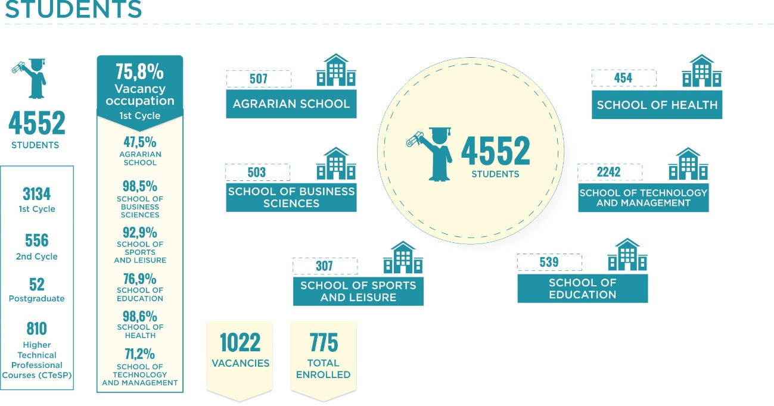
Figure 6. Main IPVC indicators with regard to students.
Note: The information presented has as reference the academic year of 2019/2020
Should the distribution of students by school be analysed, the ESTG stands out, with a total of 2,242 students, of whom 1,603 attend 1st cycle courses, 246 2nd cycle courses and 393 CTeSP courses. This is followed by ESE, with 539 students, divided into the 1st cycle (293), 2nd cycle (112), postgraduate courses (15) and CTeSP (119); ESA, with 507 students, divided into the 1st cycle (316), 2nd cycle (28) and CTeSP (163); ESCE, with 503 students, divided into the 1st cycle (394), 2nd cycle (32), postgraduate courses (37) and CTeSP (40); ESS, with 454 students, divided into 1st cycle (321), 2nd cycle (89) and CTeSP (44); and finally, ESDL, which has a total of 307 students, divided into the 1st cycle (207), 2nd cycle (49) and CTeSP (51).
Between the academic years of 2017/2018 and 2019/2020, there was an increase of about 0.8% in the total number of students enrolled in the IPVC (from 4,514 in 2017/2018 to 4,552 in 2019/2020). Mention should be made of the increase in the number of students in the CTeSP (8.1%, corresponding to an increase of 61 students) and the decrease in the number of students at the master's level (21.1%, corresponding to a decrease of 149 students (Figure 7).

Figure 7. Students enrolled in the IPVC, in the academic year of 2019/2020, by level of education.
Source: IPVC, December 2019
With regard to the geographic origin of the students, almost half (48.7%, in the academic year of 2019/2020) are residents of the Alto Minho region. This percentage is lower than the level of 1st cycle students (44.7%) and higher among graduate students (67.3%) and CTeSP (60.1%).
In the current academic year, 95 students with foreign nationality are enrolled in the IPVC (about 2.1% of total students). This data does not include students enrolled under the International Student Status or on credit mobility.
With regard to the occupancy rate (ratio between the number of students enrolled and the number of vacancies), between the academic years of 2017/2018 and 2019/2020, there was a slight decrease in this rate in the 1st cycle courses (considering the national contest for access to higher education and the special regimes and tenders). At the level of the 2nd cycle and CTeSP, there has been some stability in occupancy rates over the years (Table 7).
Table 7. Occupancy rates at different levels of education at the IPVC
Courses | Occupancy Rate
 | 2019/2020 | 2018/2019 | 2017/2018
1st cycle | 75,9% | 71,9% | 76,2%
2nd cycle | 67,8% | 67,1% | 68,7%
Higher Professional Technical Course (CteSP) | 76,9% | 78,3% | 74,3%
Source: IPVC, December of 2019
Should the occupancy rate of IPVC courses be intersected with the unemployment rate of graduates from those same courses and compared with the unemployment rate of graduates at a national level, it appears that there is a set of courses with unemployment levels above the national average, some with little demand but others with high occupancy rates.
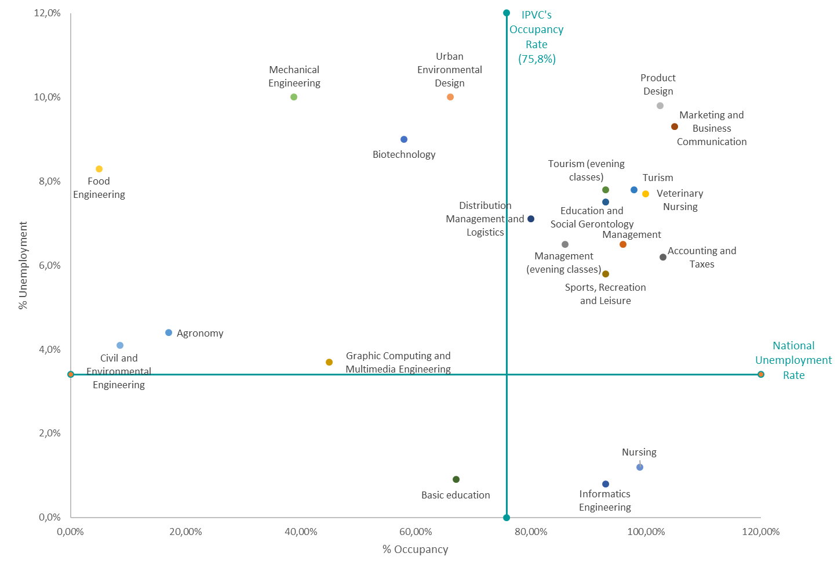
Figure 8. Occupancy rates for IPVC courses and unemployment rate for graduates
Source: IPVC, December 2019 and General Directorate for Education and Scientific Statistics - Higher education data and statistics (http://infocursos.mec.pt/) (accessed in January 2020)

In the academic year of 2018/2019, 1,754 students graduated from the IPVC (1st cycle, 2nd cycle and CTeSP). Of the total graduates, 67.8% (1,190) completed 1st cycle courses, 26.3% (462) CTeSP and 5.8% (102) 2nd cycle courses.

HUMAN RESOURCES
In the academic year of 2019/2020, the IPVC has 391 teaching staff and 191 non-teaching staff (Figure 9). In the present academic year, the 391 teachers correspond to 270.5 FTE.
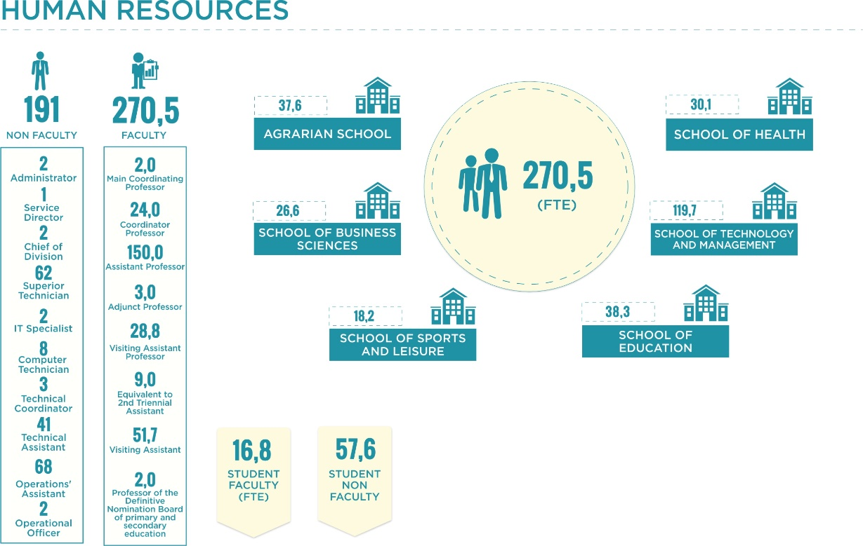
Figure 9. Main IPVC indicators with regard to human resources.
Note: The information presented is based on the academic year of 2019/2020.
If we analyse the distribution of teachers by category, the assistant professors stand out, by representing about 55.5% of the total FTE (Table 8).
Table 8. Distribution of teachers by category
Category | N.º | FTE
Main Coordinating Professor | 2 | 2,0
Coordinator Professor | 24 | 24,0
Assistant Professor | 150 | 150,0
Adjunct Professor | 3 | 3,0
Visiting Assistant Professor | 44 | 28,8
Equivalent to 2nd Triennial Assistant | 9 | 9,0
Visiting Assistant | 157 | 51,7
Professor of the Definitive Nomination Board of primary and secondary education | 2 | 2,0
Total | 391 | 270,5
Source: IPVC, December of 2019
The School with the highest number of teachers the school year in question is the School of Technology and Management with 119.7 ETI. This is followed by the School of Education with 38.3, the Agrarian School with 37.6, the School of Health with 30.1, the School of Business Sciences with 26.6 and, finally, the School of Sport and Leisure with 18.2.
On the other hand, between the academic years of 2017/2018 and 2019/2020, the total number of IPVC teachers decreased by approximately 7.9% (from 422 to 391 teachers). However, if the evolution in terms of FTE is analysed, there is an increase of approximately 1.3% (from 267.0 to 270.5 FTE).
Of the 381 IPVC professors, the vast majority have PhDs (218) or a master's degree (103). It should also be noted that about 48.5% of IPVC teachers are over 50 years old.
With regard to non-teaching staff, at the end of 2019, the IPVC had 191 non-teaching staff. Should the distribution of non-teaching staff be analysed by category (Table 9), operational assistants stand out with 35.6% of the total number, which corresponds to 68 employees.
Table 9. Distribution of non-teaching staff by category
Category | N.º
Administrator | 2
Service Director | 1
Chief of Division | 2
Superior Technician | 62
IT Specialist | 2
Computer Technician | 8
Technical Coordinator | 3
Technical Assistant | 41
Operations’ Assistant | 68
Operational Officer | 2
Total | 191
Source: IPVC, December of 2019
Regarding the distribution of non-teaching staff by structure (Table 10), at the end of 2019 Social Services stood out with 34.0% of the total number (65 employees), followed by the Central Services with 22.5% (43 employees).
Table 10. Staff plan, by category and structure
Category | ESA | ESCE | ESDL | ESE | ESS | ESTG | Central Services | Social Services | OTIC | Library | Total
Administrator | 0 | 0 | 0 | 0 | 0 | 0 | 1 | 1 | 0 | 0 | 2
Service Director | 0 | 0 | 0 | 0 | 0 | 0 | 1 | 0 | 0 | 0 | 1
Chief of Division | 0 | 0 | 0 | 0 | 0 | 0 | 2 | 0 | 0 | 0 | 2
Superior Technician | 5 | 5 | 1 | 2 | 1 | 13 | 21 | 4 | 3 | 9 | 62
IT Specialist | 0 | 0 | 0 | 1 | 0 | 1 | 0 | 0 | 0 | 0 | 2
Computer Technician | 2 | 0 | 0 | 1 | 0 | 2 | 2 | 1 | 0 | 0 | 8
Technical Coordinator | 0 | 0 | 0 | 1 | 1 | 0 | 1 | 0 | 0 | 0 | 3
Technical Assistant | 5 | 2 | 0 | 2 | 5 | 7 | 8 | 11 | 1 | 0 | 41
Operations’ Assistant | 5 | 0 | 0 | 6 | 2 | 2 | 7 | 46 | 0 | 0 | 68
Operational Officer | 0 | 0 | 0 | 0 | 0 | 0 | 0 | 2 | 0 | 0 | 2
Total | 17 | 7 | 1 | 13 | 9 | 25 | 43 | 65 | 4 | 9 | 191
Source: IPVC, December of 2019

When calculating the student-teacher (ETI) and student/non-teacher ratios of IPVC per School, we see that, in the school year of 2019/2020, the Schools with the lowest number of teachers are the Agrarian School and the School of Education (with 13.5 and 14.1 respectively). As far as non-teaching staff are concerned, the results are identical to those observed for teaching staff (29.8 Agrarian School and 35.9 School of Education).
In addition to the staff map, there are also a number of services that are provided by companies or individual service providers.

RESEARCH & DEVELOPMENT (R&D)
The IPVC comprises seven research units, three of which have the Polytechnic as their main management institution and four of which are associated with an external institution. Figure 10 shows some indicators of the IPVC with respect to R&D.
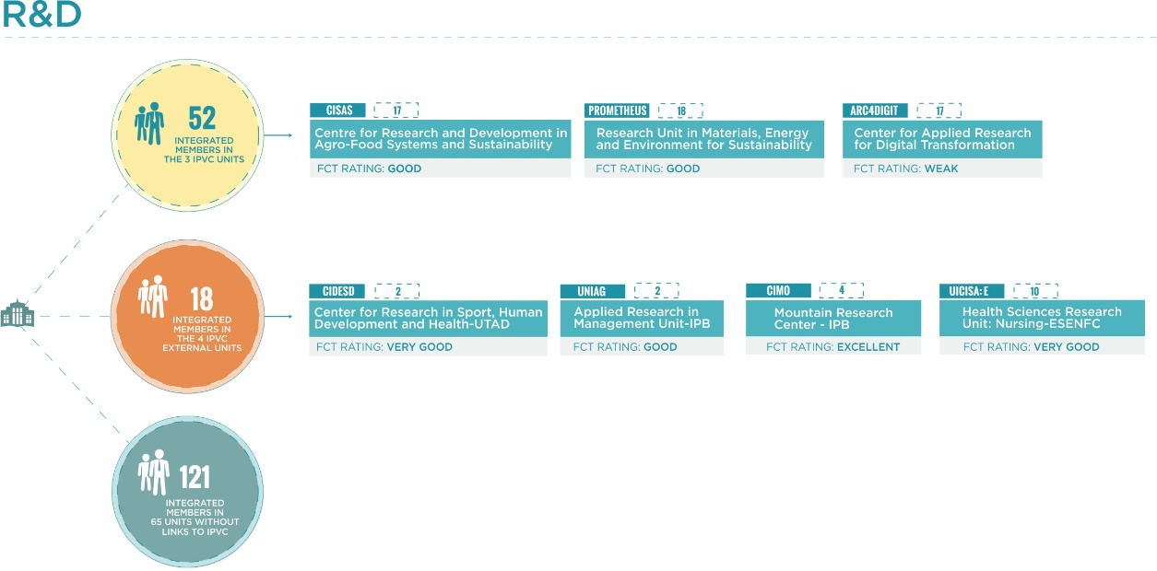
Figure 10. Main IPVC indicators with regard to research and development.

The research units that have the IPVC itself as their main management institution are:
- Centre for Research and Development in Agro-Food Systems and Sustainability (CISAS);
- Research Unit in Materials, Energy and Environment for Sustainability (proMetheus); and
- Center for Applied Research for Digital Transformation (ARC4DigiT).
In the evaluation carried out by the Foundation for Science and Technology (FCT) in 2017/2018, CISAS and proMetheus obtained a classification of Good and ARC4DigiT of Weak.
There are also four research units associated with an external institution. The research units which are associated with an external institution are:
- Center for Research in Sport, Human Development and Health (CIDESD);
- Applied Research in Management Unit (UNIAG);
- Mountain Research Center (CIMO); and
- Health Sciences Research Unit: Nursing (UICISA: E).
In the evaluation performed by FCT, CIMO obtained a classification of Excellent, CIDESD and UICISA: E Very Good, and UNIAG Good.
All three R&D units based at the Polytechnic are associated with 52 integrated members, while the four R&D units associated with an external institution have 18 integrated members of the IPVC. It should be noted that there are still a significant number of IPVC teachers (121) who are integrated members or collaborators of external centres (49 in total) who do not have apparent significant links to the Polytechnic. Of these 121 teachers, 38 are spread over 10 centres which have at least 2 IPVC teachers as integrated members or staff members. (Table 11).
Table 11. Distribution of IPVC teachers as integrated members or collaborators in external Research Units
Research Unit | Nº of integrated IPVC members/ collaborators
University of Minho Centre for Research in Child Studies (CIEC) | 12
Centre ALGORITMI | 5
CITUR - Centre for research, development and innovation in tourism | 5
CEMRI - Centre for Migration Studies and Intercultural Relations | 3
Centre for Humanistic Studies of the University of Minho (CEHUM) | 3
CIAUD - Centre for Architecture, Urbanism and Design Research | 2
CIED - Education Research Centre | 2
CINTESIS - Health Information Systems and Technologies Research Centre | 2
INESC TEC | 2
GI SCD (Research Group on Health, Culture and Development) | 2
Source: IPVC, December of 2019
In addition, there are 39 external centres each with an integrated member or collaborator of the IPVC.
As a result of the FCT evaluation, the total funding foreseen for the seven research units that integrate the IPVC amounts to 7.3 million euros for the period of 2020-2023 (980.4 thousand euros for the three centres that have the IPVC as their main management institution). Calculating the funding per integrated member, CISAS is worth around 32.6 thousand euros, followed by UNIAG with 30.6 thousand euros.
With regard to scientific publications, according to data from the Web of Science, between 2017 and 2019, IPVC teachers published 182 articles in international scientific journals with peer review, a result that places the IPVC in 5th place among all national polytechnics.
Regarding the 10 most relevant scientific domains of the articles published in international scientific journals (Figure 11), sport sciences (linked to the School of Sport and Leisure) with 36 articles and environmental sciences (linked to the Agrarian School, the School of Sport and Leisure, the School of Education and the School of Technology and Management) 14 articles stand out.
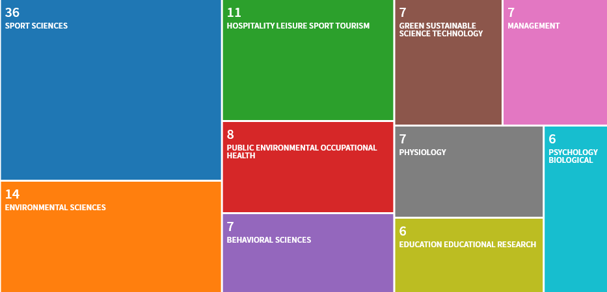
Figure 11. Ten most relevant scientific areas of articles published in international scientific journals
Source: Web of Science (https://www.webofknowledge.com/) (Accessed in January 2020)
In turn, if we analyse the institutions that co-authored the articles published in the international scientific journals (Figure 12), the University of Porto (with 37 articles), the Institute of Telecommunications (with 26) and the University of Aveiro and the University of Minho (both with 18) all deserve mention.
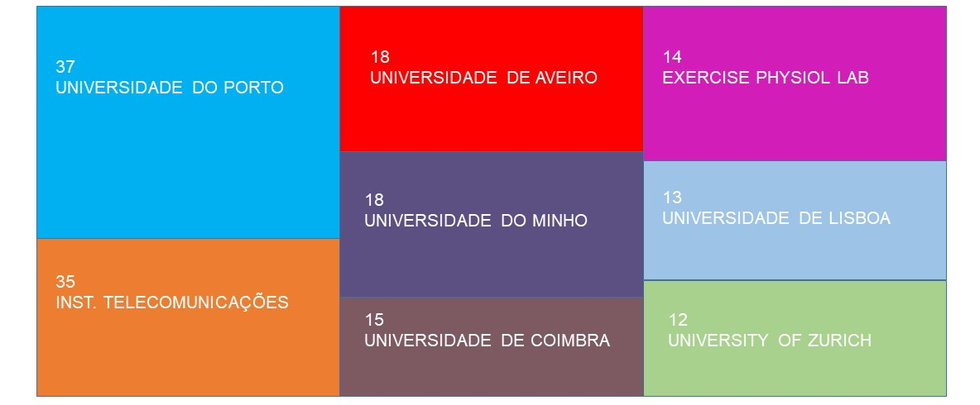
Figure 12. Main co-authoring institutions of articles published in international scientific journals
Source: Web of Science (https://www.webofknowledge.com/) (Accessed in January 2020)

Seven research projects involving the IPVC (two as coordinator and five as partner) were approved in 2018, financed under FCT programmes, the Competitiveness and Internationalisation Operational Programme (COMPETE 2020), the North Regional Operational Programme 2014-2020 (North 2020), the Rural Development Programme (RDP 2020) and the Mar 2020 Operational Programme.
Between 2016 and 2018, 35 R&D projects were started, representing a total incentive of 3.9 million Euros (Table 12). The COMPETE 2020 (12 projects, EUR 1.7 million incentive), NORTHERN 2020 (11 projects, EUR 848 thousand) and MAR 2020 (only one project, with an incentive of EUR 688 thousand) programmes stand out in terms of number and amounts involved.
Table 12. IPVC’s R&D projects approved in 2016, 2017 and 2018.
Source of funding | Denomination | Organic unit | IPVC approved value (€) | Starting year | Year End
FCT | CIMO - Mountain Research Centre FCT Miguel BRITO 2017 | ESA | 8.000 | 2018 | 2018
 | FCT/CAPES - Development of low energy geopolymetric hydraulic coatings from industrial solid waste for application in the passive control of the air quality of the built environment | ESTG | 9.000 | 2016 | 2018
 | UID/GES/4752/2016 - UNIAG | ESTG | 13.409 | 2016 | 2018
FCT/POCI | COCOON - Combined sustainable strategies for nematode management | ESA | 86.640 | 2016 | 2019
 | PORBIOTA | ESA | 226.150 | 2017 | 2020
MAR 2020 | Technical model of intensive frog production Rana perezi | ESA | 688.495 | 2018 | 2020
NORTE 2020 | ACCESS4All - Sustainable Mobility and Accessibility for All in Tourism in the Algarve | ESTG | 7.532 | 2017 | 2019
 | DeCodE - Making natural colorants and preservatives a real alternative to artificial additives through an open information and applied research strategy based on experience | ESA | 17.982 | 2017 | 2019
 | DEM@BIOFUMADOS - Biofumados Demonstrator - Tradition vs Quality - Portuguese Traditional Sausage and Smoked Products Production | ESTG | 125.967 | 2017 | 2018
 | Actinidia Operational Tool for Sustainable Bacterial Cancer (Psa) Management | ESA | 148.252 | 2018 | 2020
 | Driving the Development of the IPVC's Strategy for Internationalisation of Academic Research | Transversal | 156.020 | 2018 | 2020
 | MAINTENANCE4.0 Intelligent and Predictive Maintenance Management and Production Systems | ESTG | 15.841 | 2017 | 2019
 | Next Generation Business Solutions | Transversal | 226.580 | 2018 | 2021
 | NMSPCAM - Videomapping (pcam_vm - cultural heritage of the Alto Minho in videomapping) | ESTG | 105.935 | 2017 | 2019
 | Tourism and Heritage Routes with Intelligent Environments Adaptable to Visitor Profile and Context | ESTG | 19.627 | 2017 | 2018
 | SAFECARE - Clinical supervision for safety and quality of care NORTE-01-0145-FEDER-023654 | ESS | 12.761 | 2017 | 2019
 | Living in Grandma's house | ESTG | 11.923 | 2017 | 2019
PDR2020 | BioChestnut- IPM - Implementing of effective strategies to combat chestnut and almond tree diseases | ESA | 32.215 | 2017 | 2020
 | BioPest - Integrated strategies to combat key pests in dried fruit and nuts species | ESA | 34.044 | 2016 | 2020
 | Climcast | ESA | 19.157 | 2017 | 2021
 | Phytosanitary protection strategies for sustainable apple production | ESA | 33.705 | 2017 | 2021
 | Afforestation of Agricultural Land with More Forestry, Innovation and Value (FTA+siv) | ESA | 28.799 | 2018 | 2021
POCI | AgeNortC - Aging, Active Life, and Early Dependency Detection | ESE | 78.807 | 2017 | 2018
 | ALTO MINHO. SMOB - Sustainable mobility for the Alto Minho | ESCE | 133.691 | 2017 | 2019
 | Riceplus - Development of innovative technological and nutritional functionalisation solutions for Carolino rice | ESTG | 190.087 | 2018 | 2020
 | Turnout - Development of Outdoor Tourism in the Northern Region of Portugal | ESTG | 69.275 | 2018 | 2021
 | GMovE+: An intervention programme to promote physical activity and quality of life for the elderly population of Guarda | ESDL | 7.134 | 2017 | 2019
 | Healing - Regeneration of materials in solid oxide fuel cells | ESTG | 173.979 | 2018 | 2021
 | Mobilisation of scientific and technological knowledge in response to the challenges of the agri-food market | ESTG | 126.406 | 2017 | 2020
 | PARRA - Integrated Platform for Monitoring and Evaluation of the Golden Glavescence in the Vineyard | ESA | 143.648 | 2016 | 2019
 | PIGS&CARE - Optimization of the production of heavy pig carcasses in a natural and zealous way without resorting to castration, targeting new meat products without residues and high added value. | ESTG | 231.638 | 2017 | 2019
 | RnMonitor: Online Monitoring Infrastructure and Active Radon Gas Mitigation Strategies in Public Buildings in the Northern Region of Portugal. | ESTG | 132.300 | 2017 | 2019
 | Terr@lva: The Influence of terroir on the quality of wines: a case study of the Alvarinho varieties | ESA | 118.872 | 2017 | 2019
 | Integral valorisation of marine resources: potential, technological innovation and new applications | ESTG | 377.204 | 2017 | 2020
POSEUR | GESVESPA - Working group for assessing regional scale environmental risks and best guidance practices on control and preventing the spread of exotic Vespa velutina in northern Portugal | ESA | 38.130 | 2016 | 2018
Source: IPVC, December 2019

In 2018, the above projects represented a total funding for the IPVC of approximately EUR 1.5 million. In this context, the Agrarian School and the School of Technology and Management stand out, with supporting amounts of 873,000 and 364,000 euros respectively.
Additionally, according to data from the National Innovation Agency (ANI), between 2008 and 2018 71 applications for R&D and innovation projects were submitted to QREN and Portugal 2020 involving the IPVC, of which 41 were approved. During this period, the IPVC took 6th place in terms of applications approved by all polytechnics.
Finally, within this framework programme, the IPVC participated in a project funded under the Horizon 2020 programme (which ran from 2015 to 2019).

SERVICE DELIVERY AND DEVELOPMENT OF INNOVATION PROJECTS
The services provided by the IPVC (linked to training, R&D and innovation activities) in the year 2018 generated a return of 341,000 euros (Figure 13). In the overall IPVC budget, sales and services rendered account for about 2.1% of the total income.

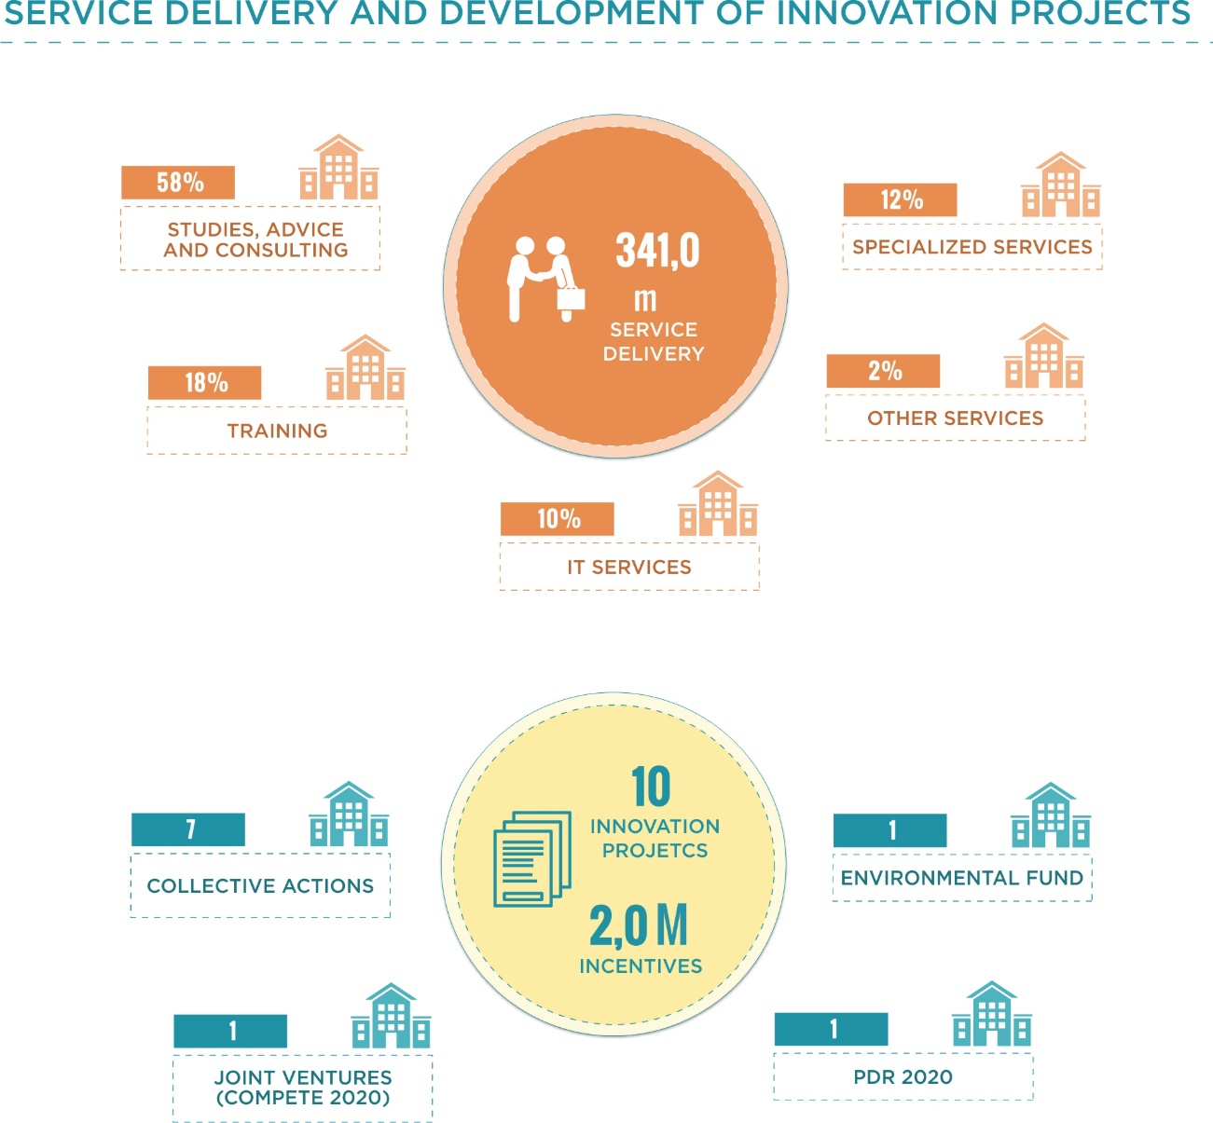
Figure 13. Main IPVC indicators regarding service delivery and development of innovation projects
Note: The information presented is for the year of 2018
In recent years the IPVC has promoted or participated in different innovation projects, within the framework of the Collective Action Support System (Table 13). In this context, between 2016 and 2018 the IPVC had seven projects approved, two of which were coordinated by the Polytechnic (Ativar and RevitAGRI-PNPG) and five (+Agro, EMER-N, CompetiTUR, PIN and TERR@ENO) by other entities.
Table 13. IPVC Innovation Projects
Project title | Typology | IPVC Promotor | Organic Unit | IPVC approved value (€) | Overall Project Value (€) | Year Start | Year End
+ Agro - Organisational, energy and occupational safety and health qualification of the agro-food industry | Support system for collective actions - "qualification | No | ESTG | 129.648 | 1.018.013 | 2016 | 2018
Revitagri-PNPG - Revitalisation of the traditional productive sectors of the PNPG |  | Yes | ESA | 574.864 | 574.864 | 2017 | 2019
TERR@ENO - Terroir and agro-ecological zoning for the economic valorisation of the landscape and wine production in the sub-regions of Monção and Melgaço and Lima, of the Vinho Verde Region |  | No | ESA | 330.190 | 773.141 | 2017 | 2019
Peneda-Gerês CompetiTUR - Competitiveness of tourism SMEs in Peneda-Gerês | Support system for collective actions for low-density territories - "qualification | No | ESDL | 81.809 | 546.675 | 2016 | 2018
ATIVAR the Regional Knowledge Sharing and Valorisation Interface | Support system for collective actions "transfer of scientific and technological knowledge | Yes | Transversal | 665.801 | 665.801 | 2017 | 2019
EMER-N - Entrepreneurship in the Northern Region | Support system for collective actions - "promotion of entrepreneurship | No | ESA | 84.600 | 1.999.200 | 2016 | 2018
PIN – Poli Entrepreneurship Innovation Network |  | No | Transversal | 39.957 | 703.032 | 2016 | 2017
Source: IPVC, December of 2019

INTERNATIONALISATION
In the current school year, 95 of the IPVC's total students are of foreign nationality. It should also be noted that in the academic year of 2018/2019, 131 incoming students came to study at the Polytechnic and 98 IPVC students went abroad. (Figure 14).

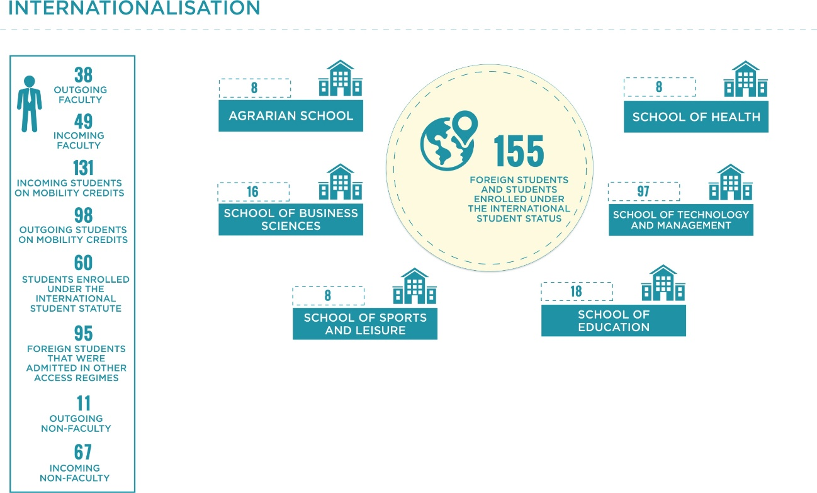
Figure 14. Main IPVC indicators regarding internationalisation
Note: The information presented refers to the academic year of 2019/2020 for foreign students and the academic year of 2018/2019 for Erasmus.

Between the school years 2016/2017 and 2018/2019, there was a 38.8% reduction in the number of students (from 160 to 98) who went to study in other countries under credit mobility programmes (such as Erasmus+), with Spain standing out as the destination country for these students. In the same period, there was also a 13.8% reduction in the number of incoming mobility students (from 152 to 131), with Poland standing out as the country of origin for a larger number of students.
Of the IPVC students who went to other countries for the academic year 2018/2019 under credit mobility programmes, the majority (72.4%) were enrolled in the School of Technology and Management.

Contrariwise, there has been an increase of more than 200% in the number of students enrolled in the IPVC under the International Student Charter (from 19 to 60) between the academic years 2017/2018 and 2019/2020. In the current academic year, more than half of the 60 students enrolled under this statute come from Cape Verde. Of the students enrolled under the International Student Charter, 60% (corresponding to 36 students) study at ESTG-IPVC.
As regards teacher mobility, between the academic years of 2016/2017 and 2018/2019 there was a 19.1% reduction in the number of IPVC teachers going to other countries (from 47 to 38), being that Spain stood out as the destination country, as in the case of students. There was also a decrease in the number of foreign teachers coming to teach at the IPVC (14.0%, from 57 to 49), with Spain and Poland standing out as the countries of origin of these teachers.
In addition, 26.3% of IPVC teachers who were mobile in other countries in the academic year of 2018/2019 belonged to ESTG-IPVC. They were followed by ESS-IPVC with 21.1% and ESE-IPVC with 18.4%. On the other hand, of the teachers who came in mobility to the IPVC in the academic year of 2018/2019, 40.8% were associated to the ESTG-IPVC.
As regards projects financed by European and European territorial cooperation programmes, between 2016 and 2018, 12 projects in which the IPVC has participated (four as coordinator and eight as partner) have started, with a budget for the Polytechnic of around 1.8 million euros. Of these, the projects coordinated by the IPVC are all funded under the Erasmus+ programme (Table 14).
Table 14. IPVC projects funded by Erasmus+
Project title | Organic Unit | IPVC promotor | Approved amount IPVC (€) | Overall Project Value (€) | Year Start | Year End
ERASMUS+ International Credit Mobility | Transversal | Yes | 137.290 | 137.290 | 2016 | 2018
INCOME – Strategies for development of Soft skills in the tourism professional setting | ESTG | Yes | 115.865 | 999.818 | 2018 | 2020
IRUDESCA – Regional Integration, University and Sustainable Development in Central America | ESTG | Yes | 76.158 | 801.554 | 2016 | 2018
Now Portugal | Transversal | Yes | 116.408 | 524.610 | 2016 | 2017
EFFORT: Education Force: Driving Mobility for EU-East Europe Cooperation Erasmus Mundus 2009-2013 | ESTG | No | 359.779 | 3.241.900 | 2016 | 2017
IN COMMON SPORTS – Intergenerational Competition as Motivation for Sport and Healthy Lifestyle of Senior Citizens | ESDL | No | 31.150 | 316.986 | 2018 | 2020
Source: IPVC, December of 2019
Between 2016 and 2018, six other projects funded under international programmes have also started: four international cross-border projects funded under the INTERREG V-A Spain-Portugal Cross-Border Cooperation Programme (POCTEP 2014-2020), one transnational project funded under the Southwest European Space Territorial Cooperation Programme (SUDOE) and one project funded under the Development Education and Awareness Raising Programme (DEAR) (Table 15).
Table 15. Other IPVC international projects
Project Title | Funding programme | Organic Unit | IPVC promotor | Amount approved IPVC (€) | Overall Project Value (€) | Year Start | Year End
BIOMASA_AP - Improvement of biomass research capacities, for an optimised energy use of non-valued but high-potential biomass in the Euroregion | POCTEP 2014-2020 | ESTG | No | 170.598 | 2.249.736 | 2017 | 2019
ECODESTIN - Natural and nautical destinations, accessible, integrative, intelligent and international | POCTEP 2014-2020 | ESDL | No | 92.758 | 189.9852 | 2017 | 2019
FORVALUE: innovative management for the enhancement and resilience of the forest area | POCTEP 2014-2020 | ESA | No | 98.556 | 1.370.130 | 2018 | 2021
EDIT: Euroregion Intelligent Tourist Destination | POCTEP 2014-2020 | ESTG | No | 197.500 | 2.314.707 | 2018 | 2021
Get Up and Goals! | DEAR | ESE | No | 262.994 | 3.925.271 | 2017 | 2020
REDVALUE - Technological alliance to complete the agro-industrial and forestry production cycle | SUDOE | ESTG | No | 100.000 | 1.009.369 | 2016 | 2019
Source: IPVC, December of 2019

In the IPVC there are two structures linked to internationalisation activities: the Technology Transfer, Innovation and Knowledge Workshop (OTIC) and the Mobility and International Cooperation Department. OTIC is responsible for preparing applications for European projects (mobility not included) and for attracting non-EU students. The Mobility and International Cooperation Department is responsible for Erasmus+ mobility. In addition to these structures, the Office for Studies in Education and Development (GEED), based at the SE, which is active in promoting education and development cooperation, is also notified.

FINANCIAL SUSTAINABILITY
The main source of IPVC funding (excluding SAS) in 2018 was the transfer of funds from the State Budget, which accounted for about 63.7% of total revenues, followed by fees, fines and other penalties (19.7%)
With regard to IPVC expenditure, in 2018, personnel costs, which totalled around 74.3% of total expenditure, were highlighted, followed by the acquisition of goods and services (Figure 15).

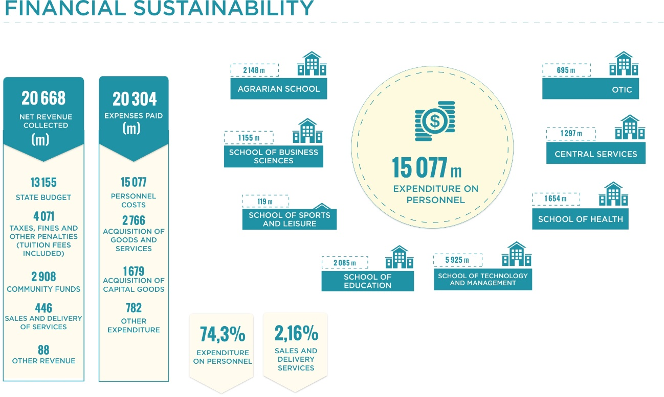
Figure 15. Main IPVC indicators with regard to financial sustainability (excluding SAS)
Note: The information presented is for the year 2018

Through the analysis of the evolution of the main budgetary indicators of the IPVC between 2016 and 2018, a decrease was observed in terms of revenue, dependence on the State Budget (less 3.6 percentage points) and, in terms of expenditure, the share of personnel expenditure (less 6.0 percentage points). With regard to the economic and financial indicators, the reduction in financial autonomy (17.4 percentage points) was noted.

The main source of financing for the SAS in 2018 was sales and services, which accounted for some 66.82 % of total revenue, followed by transfers from the State budget (20.16). As regards SAS expenditure, in 2018, purchases of goods and services stood out, accounting for around 51.69% of total expenditure, followed by personnel expenditure (Figure 15).
As regards the economic and financial indicators of the SAS-IPVC, between 2016 and 2018, an increase in financial autonomy (45.39 percentage points) is signalled. However, this increase essentially resulted from the adjuESTGent movements made during the transition to the new accounting standards - SNC-AP
- Total net revenue collected; 1.959.529,01 €
- Distribution of net revenue collected by:
  - Community funding; 96 749,62 €
  - State budget; 395 000,00 €
  - Sales and service provision; 1 309 351,09 €
  - Other revenue.158.428,30 €
- Total expenditure paid: 1 939 588,53 €
- Distribution of expenditure paid by:
  - personnel costs; 752 269,75 €
  - purchasing of goods and services; 1 002 625,5 €
  - acquisition of capital assets; 57 952,09 €
  - Remaining expenditure. 12 6741,19 €
- For personnel expenditure, the expenditure processed (obligation phase) amounted to 769 143,73 €.
With regard to personnel expenditure, the following should be noted:
In 2018, in view of the change in the rules applicable to the SNC-AP, the payment of deductions from salaries became a budgetary operation. Since the SAS carried debts over from one year to the next (within the payment period) relating to these deductions, the expenditure paid in group 01 (personnel expenditure) for 2018 is not comparable with the amounts for previous years. The comparable figures would be those corresponding to the expenditure processed, i.e. staff expenditure totalling EUR 769 143.73.

A SUSTAINABLE & INCLUSIVE CAMPUS
The IPVC's Social Responsibility Strategy focuses on the development of activities linked to social inclusion, economic and social development, environmental protection, cultural memory, artistic production and cultural heritage.
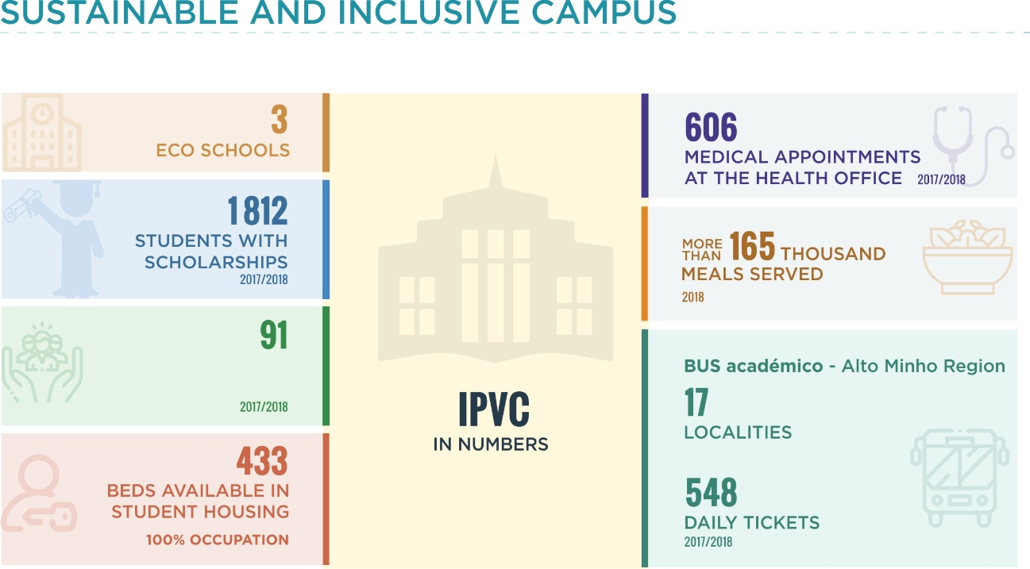
Figure 16. Main IPVC indicators for a sustainable and inclusive campus

In its Management Policy, the IPVC emphasizes the commitment to incorporate environmental ethics in all its teaching, R&D and service delivery activities, in order to make them compatible with environmental protection.
Within this context, the concept of a Sustainable Campus was developed and an "Environment" management process was created, thus disseminating the IPVC's environmental policy, which is included in the IPVC's Guide to Good Environmental Practices and focuses on the development of activities involving the different organic units of the Polytechnic and have an impact on themes of deep environmental relevance such as (i) the production of waste of various types and (ii) the optimization of resources in the field of electrical energy, air, consumables, green spaces and sustainable mobility (Electric Vehicles, U-Bike and Academic BUS).
In turn, under the Eco-Schools Programme, IPVC has developed actions for environmental sustainability and process improvement, and three of its Schools (SA, ESTG and ESE) have already been awarded the Eco-Schools award in the academic year of 2018/2019, which shows the IPVC's commitment in this area. In the academic year of 2019/2020, all the Schools of the IPVC enrolled in this programme as well as the results are not yet known.
On the other hand, the Social Services of the IPVC (SAS) are a functional unit of the Polytechnic, endowed with administrative and financial autonomy. The SAS are the structure of the Institute dedicated to ensuring the functions of the school’s social action. The organisation of the SAS has as its head the President of the IPVC and the Social Action Council (CAS), the Administrator of the Social Services and the Management Council of the Social Services.
Under Law 62/2007 of 10th September, the SAS aims to provide students with better study conditions through the provision of services and the granting of direct and indirect support:
- Direct support:
- Scholarships; and
- Emergency assistance.

- Indirect support:
- Access to food and accommodation;
- Access to health services;
- Support for cultural and sport activities;
- Access to other educational aids or grants.
The SAS is developing an increasing number of activities in health and welfare and in the areas of culture and sport.
Within this context, in the academic year of 2017/18, 2,227 students (50.4% of IPVC students) applied for scholarships, of which 1,812 students responded positively (41.0% of IPVC students). In addition, 91 students benefited from social support grants.
As regards student accommodation, 433 beds were made available in the academic year of 2017/2018 in IPVC residences. On the other hand, 606 consultations were made in the Health Office, including psychology, nursing and nutrition consultations.
In turn, as part of the strategy to strengthen services to students, the year 2017 saw the consolidation of the three projects launched at the end of 2015, namely: the Academic BUS, the Employment Bureau and the Low Cost Laundry.
In recent years, the IPVC's activity has also been marked by the promotion of welfare and active citizenship programmes, of which the Inclusive School, IPVC Senior Academy, IPVC Junior Academy and "Solidarity Actions" promoted by IPVC students stand out.
For projects related to a sustainable and inclusive campus, three projects in which the IPVC has participated/ participates as a partner started in the period 2016-2018 (Table 16). It is also important to note that in the period 2015-2018, the IPVC was the promoter of the U-Bike Portugal project: Operation IPVC, a measure of the Ministry of Environment and Energy Transition, which aims to promote smooth mobility, particularly the use of bicycles, in academic communities of the adherent public institutions of higher education (IES). Also as part of the Support Programme for Electrical Mobility, the IPVC has been investing in the purchasing of electric vehicles (Environmental Fund).
Several projects approved by POSEUR are also mentioned, which has made it possible to increase the energy efficiency of buildings through the implementation of intelligent energy management mechanisms and the use of renewable energy in infrastructures.

Table 16. Projects related to the sustainable and inclusive campus of the IPVC
Project title | Funding programme | Organic Unit | IPVC promotor | IPVC approved value (€) | Year Start | Year End
Transforming Schools: Contributions to Social Change from Education for Development and Global Citizenship at School | Camões – Institute for Cooperation and the Portuguese Language, IP | ESE | No | 139.563 | 2018 | 2020
PT/2016/FAMI/079 Implementation of the PMIIVC | High Commission for Migration | ESS | No | 11.726 | 2016 | 2017
U-BIKE PORTUGAL - OPERATION IPVC | POSEUR | transversal | Yes | 329.020 | 2015 | 2018
EcoSan - Ecological Sanitation | Environmental Fund | ESA | Yes | 49.150 | 2018 | 2019
PT/2017/FAMI/198 - Municipal Plan for the Integration of Migrants | High Commission for Migration | ESS | No | 24.914 | 2017 | 2020
Source: IPVC, December of 2019

3. SWOT Analysis

The IPVC intends to align its strategy with the Region, highlighting the Upper Minho strategy for 2030, which foresees action in five areas for the Alto Minho:

› … Smarter, promoting innovative and intelligent economic transformation;
› … Greener and hypo Carbon, promoting the transition to clean and fair energy, green and blue investments, the circular economy, adaptation to climate change and risk prevention and management;
› … More connected, promoting mobility and regional connectivity in ICT;
8 CIM Alto Minho (2013). Alto Minho Challenge 2020, Development Plan.
› … More inclusive implementing the European pillar of social rights;
› … Closer to the citizen by fostering sustainable and integrated development of urban, rural and coastal areas and local initiatives.

SWOT-IPVC associated to SOCIAL RESPONSIBILITY ASSETS (SR)
SR ASSET | Significant SR Assets for the IPVC | STRENGTHS | WEAKNESSES | OPPORTUNITIES | THREATS
Organisation's Governing | -Transparency and ethical characteristics of the activities  -Information, consultation and participation of interested parties  -Customer/consumer relations | -Shared leadership, cross-cutting bodies, including AC/GD; representative constitution of bodies and GAQ (bodies, services, PDs and PNDs, students and outsiders)  - PGRCIC since 2009 (under review)  - Comprehensive auscultation methods for PI;  -Investigations and management of complaints/suggestions/ compliments in various media: online, boxes, complaints book  - Investment in IS; On.IPVC and availability of Public Information (via Portal)  -SG certified ISO 9001 since 2008 and A3ES since 2013  - Image and information provided by IPVC evaluated as very positive (Ent. Ext. and Schools Sec/Prof)  - Strong link to the region (active participation in consortia, networks, associations, forums, platforms...)  - INNOLAB- North CSR  -Diversity in the formative offer  - IPVC SUMMIT | -Code of Conduct and Ethics (in conclusion)  -Manual internal control (under development)  - Academic Council not functioning (revision of statutes)  - RDI and OTIC management not suited to the current need (creation of UI; reduced internationalization of Research); Outdated RDI and PS process and management  - Low Level of Mobility  -Inf. little organized and under publicized about skills and scientific production (in progress Portal ATIVAR and Publication of Repository Regulation and Access Policy)  - In 2019 the PA and RA and Management Review do not yet cover aspects of SR in a structured manner  -Current IPVC Portal (inq. already shows some dissatisfaction)  -Formal IPVC Alumni Network/Portal Alumni  -Provider payment periods (2019); student debts; lack of liquidity | Recommendation 4/2019 - Corruption Prevention Council - Prevention of risks of corruption in public procurement  National Open Science Policy  Integration into the network of university libraries and the National Reading Plan in HEI  -National Initiative Digital Skills e.2030 (INCODe.2030); Strengthening the technological level in training and management processes; "Student ID in HEI".  Social Networks  RGPD and society more attentive to IT security issues | Successive changes in public policies for the HEI and in applicable legislation  Low participation in surveys
Human Rights | Right to Freedom of Expression, Religious Freedom, Thought, Sexual Orientation and Culture  Diversity; Non-discrimination  Gender Equality  Personality Rights  The right to education  Education/training for life/training of society and local communities  Reconciliation between professional, family and personal life  Recognition and rewarding of work | Functioning bodies, suggestions, praise, complaints  - Student Ombudsman  - Social Support; "Worth Studying" programme; Social Emergency  - Inclusive School  - Senior Academy  - INPEC+ PROJECT (intervention and mentoring for lifestyles, self-esteem, well-being,...)  -Host programme/Guide Friends  - Mechanisms to prevent abandonment  - Employability Promotion; Link to WEC  - Strong investment in tenders/promotion (PD and PND) over the last 3 years  --% Career and qualified teachers (>80% of TI PhDs); Inter-career mobility in the PND; progressive and sustained increase of employees in the last 4 years  -existence of RAPD and SIADAP  -Supporting employee training;  - Signature of the Conciliation Pact (single HEI) | - No regulations for ENEE (already in preparation)  - Limitations on housing supply in relation to demand; need for re-qualification of dwellings  - No regulation on the organisation of IPVC working time (already in public discussion, to be published in DR)  - Functions manual to be completed  - Some delays in performance evaluation (under correction)  - Difficulties in implementing part-time Teaching and Teaching Service Provider Assessment | Agenda 2030 for Sustainable Development (SDS)  European policy for HEI  Global Jobs Pact  National Strategy Signalling Young People Who neither Study nor Work  -New access scheme for vocational school leavers-local competition (2020)  - New legal regime for distance learning  -33.5% of the population of Alto Minho (Eurostat, 2019) between 30 and 34 years of age had a university degree (in 2018), the target being 40% by 2020 as defined by European policy.  -International students  -Incentives to reinforce accommodation, student (DL no. 30/2019)  Programme 3 on Line No. 03/SAMA2020/2019- Conciliar in the PA (IPVC made application) | - Delays in awarding state scholarships and reduction in associated value  - Mobility grants with low financial support  -Instability of partner countries and economic difficulties of PALOP international students  - Uncertainty of future skill profiles, including job profiles, new professions  -Students enrolled in high school in Upper Minho (decreased from 12,256 in 2009 to 9,363 in 2017)  -Reduction of students arriving in HE; low birth rate and emigration, strong in Alto Minho, early school leaving  -Students with an increasingly heterogeneous profile and with a higher degree of demand in relation to the services provided  -Population living in Alto Minho has been declining
Labour Practices | The Right to work and decent working conditions  Hygiene at work  Safety at work  The Right to health | - Support services Health office  -Integration in the SG, in RHU, of the sub-process Health (Safety and Occupational Health) | - SST consultation and occupational risk diagnosis performed only once (2nd Semester 2019)  - Delay in updating MAP's  - Ageing index employees in particular in ESS and ESA  - Absenteeism rate (in particular SAS)  -Lack of preventive maintenance  - Equipment Ageing | New Statute for Research Fellows  Agenda 2030 for Sustainable Development (ODS)  OIT Conventions | Risk of non-compliance with legislation on safety and accessibility, air quality, public procurement - due to lack of resources (human and financial) to implement good practices on mobility, safety and energy efficiency, involving investment in equipment and infrastructure interventions
The environment | Energy consumption, including renewable energy  Water consumption  Sustainable Mobility | -IPVC integrates sustainability into its strategy  -Qualified Technical Team  - Higher education in the field / RDI projects and highly qualified teachers  - Monitoring mechanisms  - High approval rate for applications (POSEUR,)  - IPVC Eco-Schools  - Integration into the RCS and other environmental networks  -Implementation in the AMB/MTR Process SG and new POSEUR applications and  -platform for Sustainable Ideas - Environmental Inspectors-IPVC Brigade- Participation GreenMetric Ranking (2018 and 2019)  - Sustainable IPVC Campus" sub-portal created in the IPVC Portal | - Difficulties in implementing some consumption reduction measures (elimination of plastic bottles in bars and food products packed with bread in the canteen)  - Paper purchase still high  -Difficulties in the management of some waste | - Agenda 2030 for Sustainable Development (ODS)  -POSEUR applications;  - Environment, Climate Change and Low Carbon Economy" Programme  - ABAE  Society more attentive to sustainability issues  The Minho line is a strategic link to the north coast of Portugal, therefore it is part of the Trans-European Transport Network | - Difficulty in fully complying with -Resolution Council of Ministers No 141/2018, (paper and plastic consumption and waste management)
Operational Practices  Society Development  Consumer | Cooperation with institutions  Involvement in the achievement of public purposes  Partnership relations  Knowledge sharing  Mutual development and synergies  Technological innovation for sustainable development  Respect for patents, copyright and intellectual property  Atração e retenção de talentos  Consumer health and safety  Privacy and protection of personal data  Social, cultural and leisure activities  Support for local community development  Community involvement | - Active participation in networks/consortia/Associations/incubators  - High nº Projects in partnership  - OTIC and new UIs  - IPVC-http://www.ipvc.pt/ativar ATIVAR Platform  - Inclusive School  - Participation in networks  - High no. of voluntary initiatives/education in service/promotion of active citizenship  -Intellectual property regulation  - Investment in Food Security, including training of employees  - Teachers and technicians specialising in the field of cybersecurity/data protection  - Cultural Workshop Activities; GEED  - Inclusive School | PS Regulation not yet completed (ongoing)  Incentives for scientific production (proposal under consideration)  -Patent notifications  -agreements and protocols are not organised/integrated in a database available in the IS, making it difficult to manage them and their transversal knowledge (ATIVAR platform under development)  Placement fee (effective enrolment) for some courses (in particular via CNAES)  -Master's Attractiveness and Completion Rate  - Area of information security and data protection issues by services | Support for the valorisation of RDI in HEI Polit. (SIAC, APNOR Projects,...)  Strategy and Action Plan for Digital Employability 2015-2020  -To strengthen training in strategic areas for the region and aligned with secondary/PROFESSIONAL training, in particular in TICE areas  Eclectic Alto Minho business fabric, with the manufacturing industry standing out, in particular the automotive sector, due to the presence of multinational manufacturers of automotive components  Proposal for the Creation of a Technological Interface Centre in Alto-Minho (automotive sector, pulp and paperboard manufacturing,  metal products, rubber articles, machinery and equipment)  Scientific consortium that will implement the North Coastal Observatory (CMVC; IPVC; UM; UP)  Society more attentive to IT security issues | - Alto Minho presents the lowest RDI expenditure figures at a national level, only higher than Alto Tâmega and Tâmega e Sousa (IPCTN 2017)  - “Make up" effect, where the productive units dedicate their activity to intensive production, but still far from the decision centres and the exercise of high added value activities where R&TD and Innovation are included in their various domains. It is necessary to develop the capacity to add "value" to these structures through innovation and, of course, the creation of skilled jobs.  Competition from similar HEIs and talent drain to other Organisations

4. IPVC Strategy

Purpose
A Socially Responsible Polytechnic, generator of global knowledge and potentiator of the development of the Alto Minho

Mission
The IPVC's mission is the harmonious development of the human person, the creation and management of knowledge and culture, research, science, technology and art. It has an organisational structure made up of schools united in the same mission, whose geographical dispersion facilitates the commitment to the sustainable development of the region and whose size allows for the proximity of teachers and students in a stimulating relationship to personal and professional training.

Vision
The IPVC should be an institution recognised nationally and internationally for the quality of its training. Quality based on a technically and pedagogically qualified teaching staff, in innovative training processes, supported by R&D and innovation activities developed in a symbiotic partnership with the community players, which will translate into greater notoriety and contribution to the region's development.
An institution where one wants and likes to work

Values

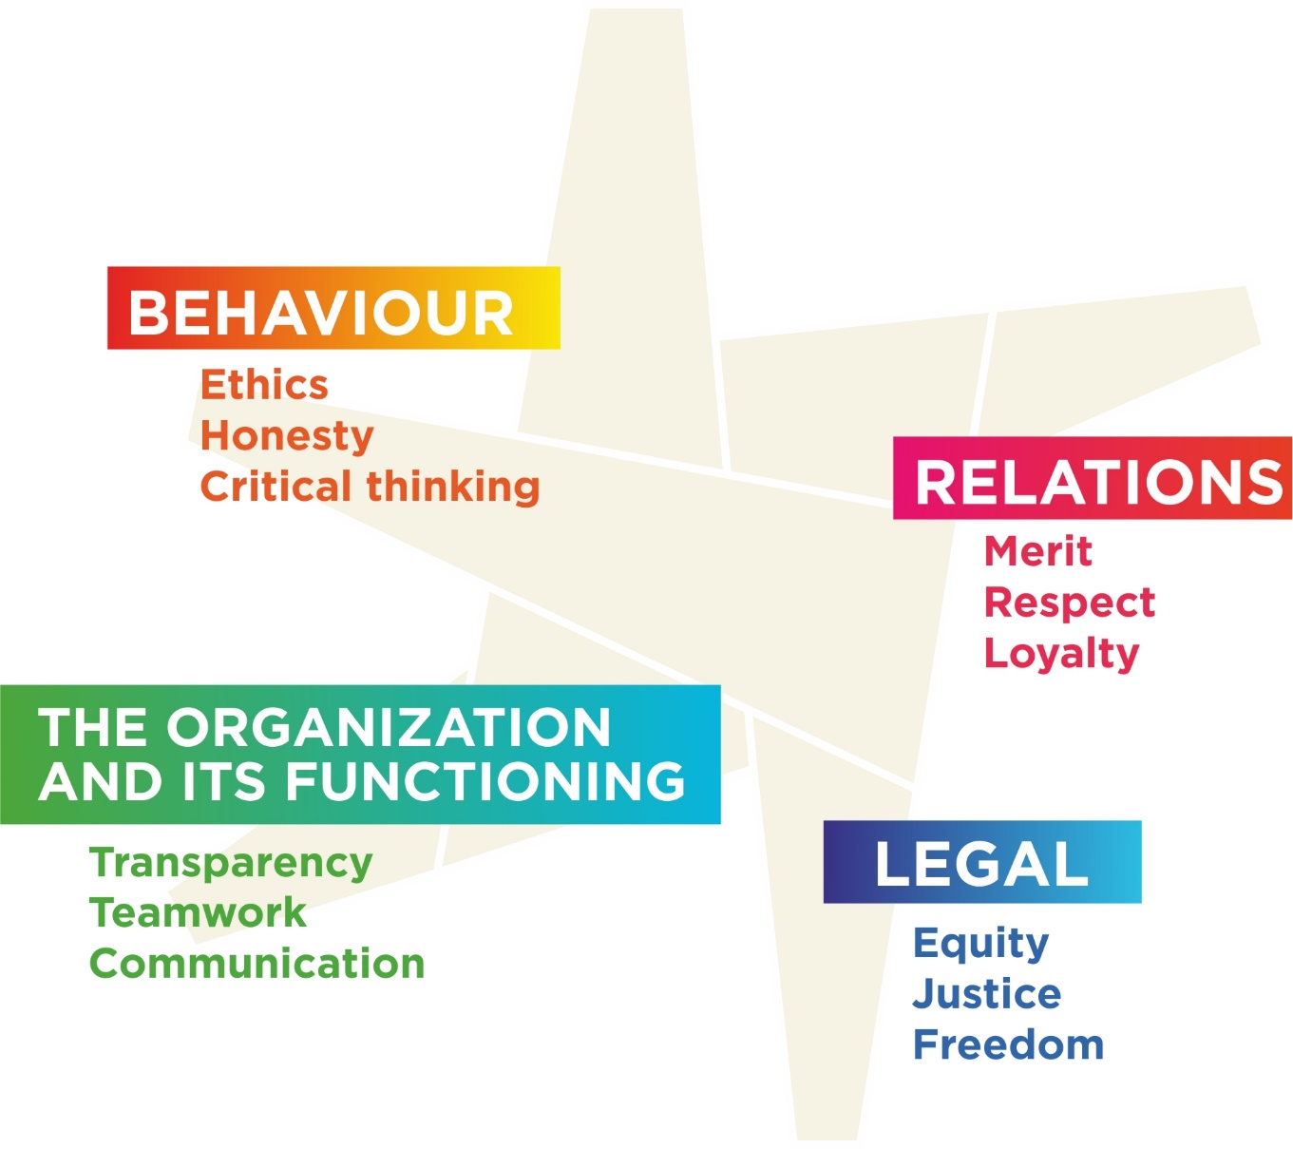

Management Policy
The Presidency of the IPVC undertakes to:
- Maintain adequate strategic planning and commitment to institutional leadership;
- To develop and maintain a strategy for the continuous improvement of the Institution, in particular the quality of the training offer, supported by an applied research practice, with a view to contributing to economic, social and environmental sustainability;
- To maintain an attitude of permanent reflection and development of the Management System (SG), which integrates quality management with social responsibility, fundamental to the fulfilment of the IPVC Mission;
- To ensure adequate communication and recognition of the SG with the IPVC Community, considering the centrality of students and the quality assurance of teaching and its improvement;
- To guarantee the necessary conditions for the pursuit of the institution's objectives;
- To promote the enhancement, recognition of merit and the reconciliation of professional, personal and family life of the people of IPVC;
- To understand the organisational context, the needs and expectations of the stakeholders (internal and external), ensuring their involvement and active and systematic participation, recognising their right to be heard and seeking to increase their satisfaction, in line with the designs and aims of the Region and the Country;
- To strengthen the conditions for the support of a policy and practice of applied research that will result in the production and transfer of knowledge that will ensure the innovation of the entrepreneurial and social fabric, from which the return on the investment made should result;
- To ensure the processes of fundamental support for greater equity in access and attendance to higher education;
- To strengthen the IPVC community’s socially responsible practices for a "Sustainable Development", in all its activities, in particular in teaching, research and service provision, in the management of the Campus and its infrastructures and in the interaction with the community;
- Comply with all applicable legal, regulatory and normative requirements, ensure respect for internationally recognised conventions and the adoption of the precautionary principle and non-regression and transparency.

Social Responsibility Aspects of the IPVC
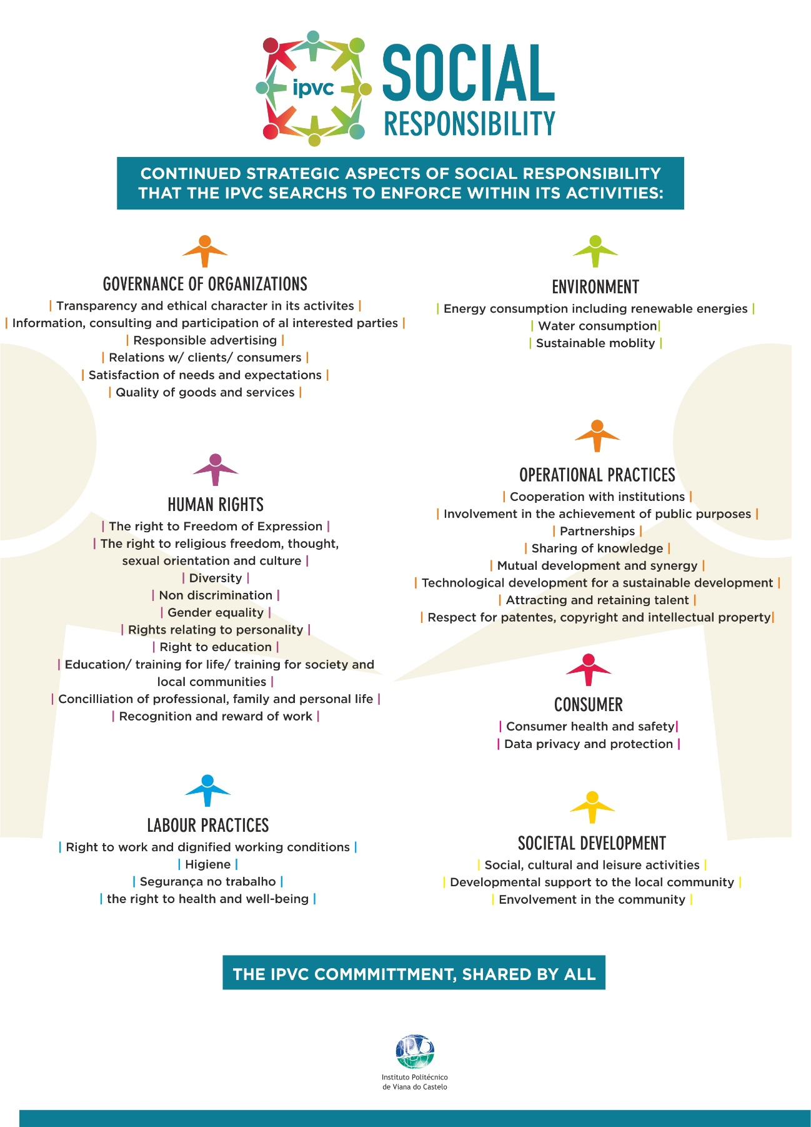

5. Strategic Axes

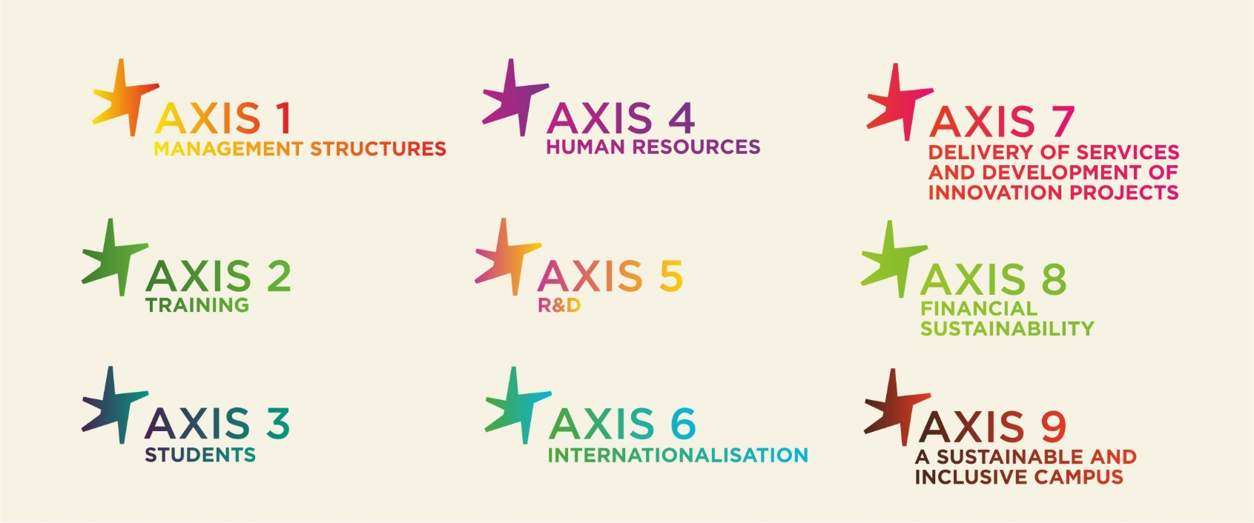

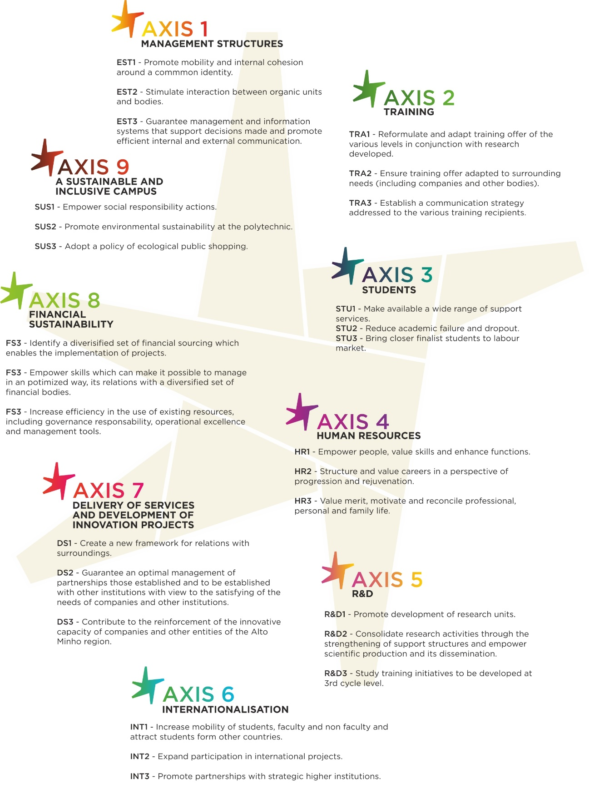

Management structures

The current reality of the IPVC presents several challenges in the management of its structures, with an impact on the efficiency of the activities developed. It is therefore important to continue to implement management systems that promote efficiency and continuous improvement and to modernise management support information systems, contributing to the Polytechnic's mission and fulfilling in the best conditions the objectives to which it has proposed itself.
It is also necessary to promote dynamics that allow the internal community to increase the feeling of belonging to the IPVC and also to the various Schools, services and units where it operates. The existence of adequate internal and external communication policies, which give visibility to the various actions which are developed and which improve the flow of information and the relationship procedures between the central services and the Schools, and within each School, is of particular importance.
In view of the above, as far as the management structures are concerned, the strategic guidelines and the resulting corollaries are as follows:
Management structures
The IPVC will be an institution with internal structures, located in the Schools or centrally positioned, which will allow it to guarantee the fulfilment of its Mission in optimum conditions.
In this sense, The IPVC will create the conditions for
EST1. Promote internal mobilisation and cohesion around a common identity | EST2. Stimulate the interaction between organic units and organs |  | EST3. Ensure that management and information systems support decision-making and promote effective internal and external communication

Training

The demands and challenges facing higher education institutions today are manifold. The skills required of students by companies and other employers are constantly changing, teaching methodologies are continuously evolving and new tools are available for training (based, for example, on the technological supports of the digital society).
In this sense, it is important that the IPVC reformulates and permanently adapts the formative offer to the needs of the environment, using teaching-learning processes appropriate to the different audiences, which include students who enter higher education through special tenders. In this context, it is fundamental to use the necessary methodologies to promote the integration of these students, minimising the risk of school drop-out and failure.
It is also relevant that the IPVC establishes a communication strategy aimed at the different recipients of the training offer (namely primary, secondary and vocational school students, foreign students and international students), which makes it possible to make known the diversity of types of training offered by the Polytechnic and to increase/ not decrease the number of its students
It is also relevant that IPVC optimally promote the teaching and higher professional technical training at the Polytechnic, as well as value the internship programs, contributing to promote the employability of students.
On the basis of the above-mentioned, the following strategic guidelines and corollaries are set out for training:
Training
The IPVC will be a higher education institution able to offer a diverse set of courses at CTeSP level, 1st and 2nd cycles, postgraduate and specialised short term training, using innovative curricula and teaching-learning processes appropriate to the various audiences, including lifelong training.
In this sense, the IPVC will create the conditions for:
FOR1. Reformulate and adapt the training offer at the different levels of education in conjunction with the research undertaken | FOR2. Providing a training offer adapted to the needs of the environment (including businesses and other entities) |  | FOR3. Establish a communication strategy aimed at different recipients of the training offer

Students
Higher education institutions today have to pay special attention to and care for their students in different ways, including the provision of support services, integration, monitoring of school careers, prevention of drop-out and promotion of school success and employability (namely through support for career management and job creation). It is important that the IPVC continue to develop actions to prevent dropping out and promote success at the Polytechnic. Among the actions that could be implemented are the creation of a network of mentors (which could include IPVC Alumni), the implementation of a pedagogical training programme for teachers including new training approaches and methodologies, and the development of improvement plans in curricular units with higher levels of failure.
It is also important that the IPVC reinforce the strategy of promoting employability from the moment the student enters the labour market, with support for the development of transversal skills that contribute to the integration in the labour market. To this end, the Polytechnic will continue initiatives already underway, including visits to potential employers in the region, the organisation and participation of students in job fairs, a training programme for employability, strengthening the interaction of the Employment Office with employers and greater dissemination of the Employment Portal and the creation of a mentoring programme in the field of career development. The participation of students in internships, including summer internships and international internships, will also be sought. The IPVC intends to invest in pedagogical innovation, in particular in the development of Learning-Service methodologies, with the implementation in all Organic Units of the "Inclusive School" concept.
On the basis of the above-mentioned, the strategic line and corollaries for the students are as follows:
Students
The IPVC will be a higher education institution able to give special attention to its students, providing a diversified set of support services and developing initiatives in different areas that contribute to promote their school success and employability.
In this sense, the IPVC will create the conditions for:
ALU1. Provide a diverse range of support services | ALU2. Reduce dropout and failure at school |  | ALU3. Bring final year students closer to the labour market

Human Resources
The success of the IPVC’s policies and image depends to a large extent on the performance of its human resources.
With regard to teaching staff, it is important to improve training at various levels. The improvement of capacity building at a pedagogical level is certainly very relevant for the achievement of quality teaching and learning processes. The improvement of capacity building is also relevant for strengthening the capacity to develop R&D projects, with applications to successful funding programmes, as well as the capacity to participate in projects proposed by other higher education institutions or other entities. The development of training for teaching staff will make the IPVC progressively more attractive to companies and other entities in the region, also contributing to the development of the area of service provision.
As far as non-teaching staff are concerned, both in terms of the service they provide to students and the technical and administrative support they provide, it is necessary to value their contributions and recognise their merit, improving motivation and increasing the efficiency of services.
The IPVC considers the development of mechanisms for the recognition of merit, the promotion of well-being and the improvement of working conditions to be essential, and to this end intends to implement a programme for the reconciliation of professional, personal and family life and the management of labour risks.
In view of the above-mentioned, as far as human resources are concerned, the strategic guidelines and the resulting corollaries are presented below:
Human Resources
The IPVC will be an institution endowed with capable and motivated human resources, enabling it to act effectively in its different areas of intervention.
In this sense, the IPVC will create conditions for:
REC1. Empower people, valuing skills and enhancing functions | REC2. Structure and enhance careers with a view to advancement and rejuvenation |  | REC3. Recognise merit, motivate and reconcile professional, family and personal life

R&D

R&D activities carried out by higher education institutions today are a key factor in attracting human resources (students and teachers/researchers) and financial resources.
In this sense, it is important to create the conditions for a new impetus for the IPVC's R&D activities, both by consolidating and developing recently established research units and by creating the conditions for the emergence of new ones, which can bring together teachers who are scattered over a large number of units from other institutions. It should be noted that for the development and consolidation of research units it is important to rethink the structures that can support them in activities such as the preparation of applications for funding programmes, the administrative and financial monitoring of projects after their approval and structures for their implementation, such as the network of laboratories installed in the IPVC Organic Units.
In addition to this, it is important that the IPVC promote a reflection on the training initiatives it should undertake at 3rd cycle level (PhDs). This reflection should address issues such as the most relevant areas for training provision at 3rd cycle level and partner higher education institutions (national or foreign) for hosting PhD students at the IPVC with the guidance/coaching of teachers / researchers at the Polytechnic.
On the basis of the above-mentioned, the following strategic guidelines and corollaries are set out:
R&D
The IPVC will carry out R&D activities of excellence that will contribute to the affirmation of the institution and that strongly influence its positioning at a regional and national level.
In this sense, the IPVC will create the conditions for:
INV1. Promote the development of research units | INV2. Consolidate research activities by strengthening support structures and boosting scientific production and its dissemination |  | INV3. Study the training initiatives to be developed at 3rd cycle level

Internationalisation

Strengthening internationalisation, in its many facets, is one of the main priorities of the IPVC in the period of 2020-2024. It is therefore important to establish partnership relations with higher education institutions and other foreign entities that will enable the Polytechnic to improve its skills and consequently strengthen its capacity in the areas of education (e.g. through the establishment of dual degrees) and R&D. In the case of teaching, the IPVC will seek to ensure that a significant number of its students can participate in outgoing mobility programmes (e.g. by establishing new collaborations with a view to boosting internships under Erasmus+) and, at the same time, will seek to attract students from other countries, namely the Portuguese-speaking African Countries (PALOP) and the destination countries of Portuguese emigration. To achieve these objectives, the Polytechnic will, among other initiatives, define the strategic higher education institutions with whom it should establish collaborations in the area of mobility and identify events, exhibitions, fairs and other initiatives in the field of education and training, with an international scope, in which it should participate to disseminate its training offer.
Regarding R&D, the IPVC will seek to increase its involvement in international projects, paying particular attention to the opportunities existing for Horizon 2020 and future Horizon Europe.
In view of the above-mentioned, as far as internationalisation is concerned, the strategic guidelines and the resulting corollaries are presented below:
Internationalisation
The IPVC will pay significant attention to the internationalisation of its activities, in its multiple aspects, establishing partnership relations with higher education institutions and other renowned foreign entities.
In this sense, the IPVC will create the conditions for
INT1. Increase the mobility of students, teachers and non-teaching staff, and attract students from other countries | INT2. Increase its involvement in international projects |  | INT3. Promote partnerships with strategic higher education institutions

Provision of services and development of innovation projects
Considering the importance that the IPVC can only attach to the transfer of its competences to its environment, the provision of specialised services to companies and other entities is of particular importance.
In this sense, the Polytechnic needs to create a new framework for relations with the environment. Within this framework, issues such as the IPVC's participation in Consortia, Associations and Networks, the relevance of rethinking the support structure for the IPVC's relationship with the environment and the strengthening of the integration of members of the business community and other regional entities as guest lecturers at the various levels of education can be addressed.
It should be noted that, for the development of service delivery activity, the IPVC will seek to mobilize resources from other institutions with which it has collaborative relations, thus broadening its offer of services and reinforcing its insertion in national or international networks of competence.
Based on the above-mentioned, regarding the provision of services and the development of innovation projects, the following strategic guidelines and corollaries are defined:
Provision of services
The IPVC will be an institution capable of boosting a strong activity in the area of service delivery, based on the use of existing skills in its Schools and the mobilization of resources from other institutions, national or international.
In this sense, the IPVC will create the conditions for:
PSI1. Create a new framework for relations with the environment | PSI2. Ensure optimal management of the partnerships established/to be established with other institutions, in order to satisfy the needs of companies and other entities |  | PSI3. Contribute to the strengthening of the innovative capacity of companies and other entities of the Alto Minho

Financial sustainability

In order to promote the diversification of its funding and to reduce the dependency on funding from the Ministry of Science, Technology and Higher Education, it is important that IPVC has a good knowledge of the sources of funding to which it can access and that it is able to establish a relationship with them that favours adequate access to the amounts available.
Today there is a diverse range of funding sources, both national and international, that the IPVC can consider depending on the nature of the projects it intends to develop. The national operational programmes inserted in Portugal 2020 (such as the Regional Operational Programme for the North and the Competitiveness and Internationalisation Operational Programme) are sources of funding that IPVC has privileged, and it is important to strengthen participation in the future Portugal 2030
Cross-border/transnational and European programmes, despite the limited participation of the IPVC, are relevant sources of funding because they can allow the Polytechnic to develop various activities, notably in the areas of R&D and innovation. Creating the conditions that will allow the IPVC to start active participation in the Horizon 2020 programme and especially in the future Horizon Europe programme should be given significant priority. Priority should also be given to creating the conditions that will allow the Polytechnic to increase its revenues by providing specialised services
In the light of the above-mentioned, as far as financial sustainability is concerned, the strategic line and corollaries are set out below:
Financial sustainability
The IPVC will be an institution able to count on in a diversified range of sources of financing and in the undertaking of its different activities, responsible for complementary income to the appropriations allocated by the Ministry of Science, Technology and Higher Education.
In this sense, the IPVC will create the conditions for:
FIN1. Identify a diverse set of funding sources that will enable the implementation of their projects | FIN2. Strengthen skills that make it possible to manage, in an optimal way, their relationship with a diverse set of donors |  | FIN3. Increase the efficiency of the use of existing resources, including governance responsibility, operational excellence and management tools

A Sustainable and inclusive Campus

It is important that the IPVC angle its actions towards the development of socially responsible practices, contributing to the development of the communities in which it operates. These practices may include, for example, implementing programmes to promote an environmentally and socially sustainable Campus, as well as promoting the integration and well-being of the academic community through programmes such as INPEC+, volunteer programmes, and encouraging the IPVC's involvement in community support activities such as the Senior Academy, Junior Academy and Inclusive School.
The IPVC has been strongly committed to expanding its support services, including Social Support Grants, emergency support, transport, accommodation, food, health, sports and cultural services.
Considering the high number of students at the Polytechnic who benefit from Scholarships, it is important that the IPVC seek more answers than those that the Social Action Services have given, with reinforcement in the support to the most needy students (e.g. through the establishment of partnerships with institutions in order to extend its patronage programme).
It is also important that the IPVC pay particular attention to sustainable development issues, boosting a diverse set of actions such as the upgrading of buildings/equipment taking into account the concern for energy efficiency of the buildings, the promotion of sustainable mobility and the improvement of environmental management of the campus (seeking that the ESCE, ESDL and ESS receive, in the short term, the Eco-Schools flag, as is already the case with ESA, ESTG and ESE).
In view of the above-mentioned, as far as a sustainable and inclusive campus is concerned, the strategic guidelines and corollaries defined are presented below:
A Sustainable and inclusive Campus
The IPVC will be an institution capable of carrying out multiple activities in the field of social responsibility and sustainable development that contribute to the development of the communities and the Region in which it operates.
In this sense, the IPVC will create the conditions for:
SUS1. Strengthen actions in the field of social responsibility | SUS2. Promote the environmental sustainability of the Polytechnic |  | SUS3. Adopt a green public purchasing policy
6. The IPVC’s Plan of Action

To achieve the strategy, a set of strategic projects and initiatives directly related to the strategic guidelines and their corollaries were defined.
The strategic projects are the following:
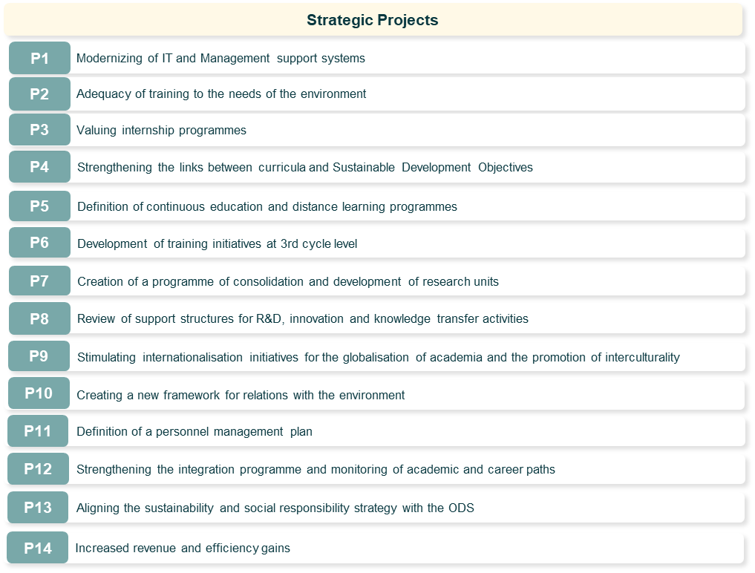

These STRATEGIC PROJECTS contribute to the achievement of the strategic axes with the following distribution:
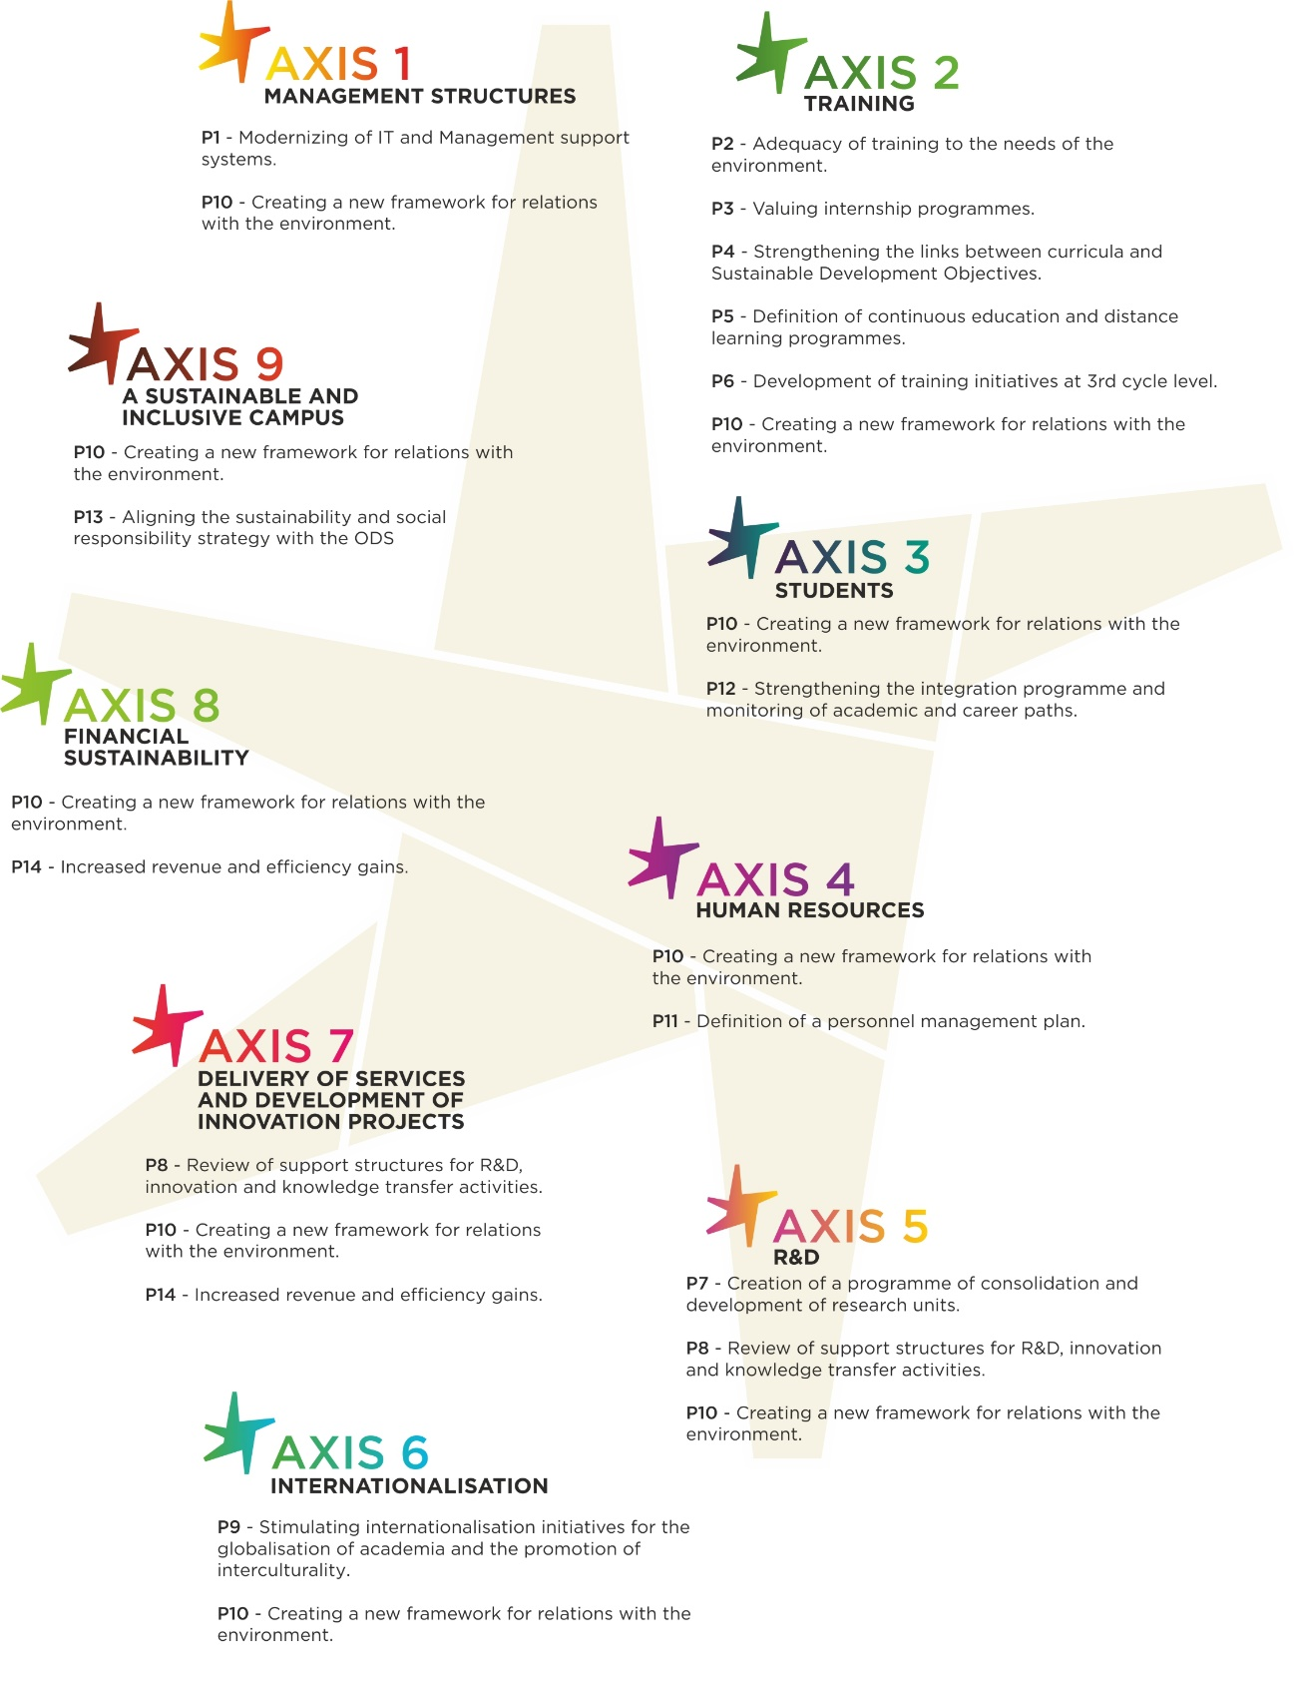

The initiatives are as follows:
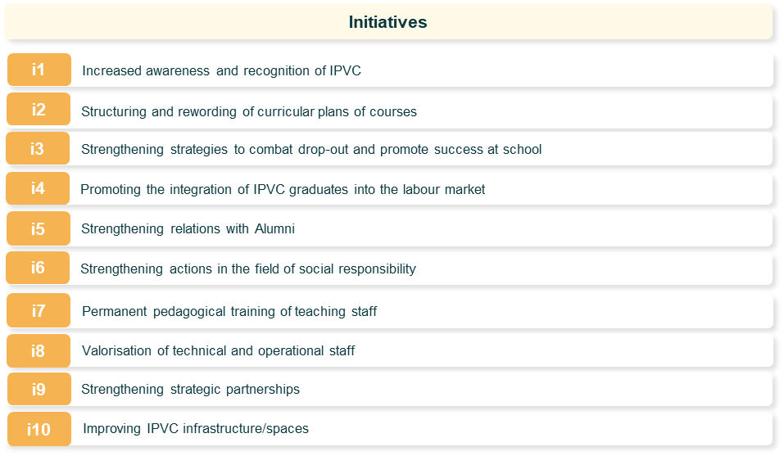

These initiatives contribute to the achievement of the strategic axes with the following breakdown:
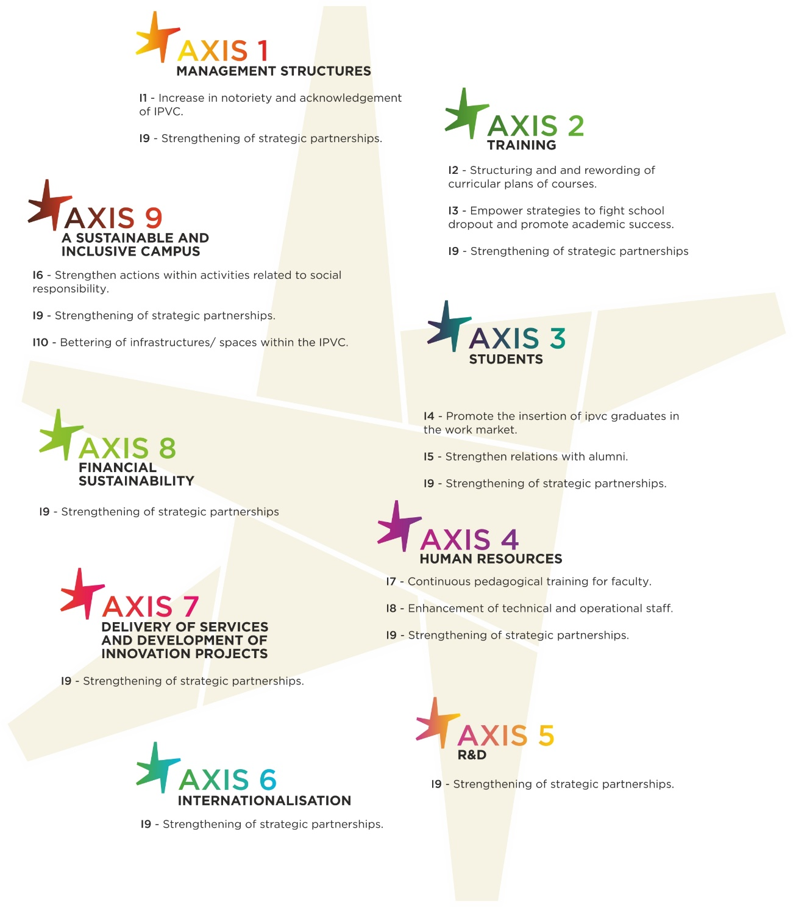
Modernisation of IT and management support systems
P1
This strategic project aims to study in detail the whole range of issues related to the rationalisation, simplification and modernisation of IPVC information systems based on the latest technological developments. Communication is, internally, essential so that everyone knows the values, principles and strategic objectives of the institution, so that the decisions taken, and what underlies them, are perceived.
Communication is also extremely important to ensure the active participation of those involved in the construction of the options inherent to the management of the institution in its multiple aspects.
Externally, communication is necessary for the awareness and dissemination of activities and the involvement of external entities and it is also necessary to listen to the needs and expectations of stakeholders in the construction of an institution that wants to serve the community. Issues to be addressed include the following:
- The dematerialisation and integration of the management system (quality, social responsibility, reconciliation, information security) and alignment with the EFQM model;
- The governance structure and operation of IT services;
- The needs of the main users of the platforms to be made available;
- The information that will be included on the platforms and the access rules;
- The dematerialisation of information flows and the document structure of the management system;
- The indicators that the platforms will provide per user profile;
- The relevance of implementing ICT training actions for teaching and non-teaching staff;
- The development of manuals of procedures and rules of use of ICT;
- The development of an institutional communication plan and the implementation of the Corporate Identity Standards Manual;
- The implementation of an effective institutional documentation archiving system and its proper preservation. The urgent completion of the Accumulated Documentation Report (RADA) and the implementation of the digital archive will contribute to this;
- The issues related to information security and data protection.
Actions will be developed for the strengthening and dematerialisation of the Management System and the necessary modernisation of the management support information systems, allowing the institution to be recognised as a reference institution, with high quality management support tools.

Adequacy of training to the needs of the environment
P2

This strategic project aims to reflect upon the training offer. Among the issues to be addressed are the following:
- The methodology to be adopted for the definition of the training offer - criteria for creation, extinction and opening of courses;
- The role of potential regional employers in the definition of the training offer;
- The articulation with regional entities in the definition and organization of internships;
- The strengthening of the integration of members of the business network in the teaching of courses, with special focus on the CTeSP;
- The choices to be made in the articulation of the CTeSP with the other levels of education of the IPVC.
Valuing internship programmes
P3

This strategic project aims to create the conditions for an effective valorisation of the internship programmes associated with IPVC training programmes. Among the issues to be addressed are the following:
  - Identification of strategic entities for the establishment of partnerships. In this area, particular attention should be paid to companies and other entities (Local Administration, IPSS, etc.) established in the Region;
  - Identification of a strategic set of multinational entities, established in the Region, that may be interested in receiving IPVC students, and that may facilitate the mobility of these students to other European countries where they have their headquarters / delegations;
  - Identification of existing opportunities for internship offers with relevant companies based abroad;
  - Analysis of the curricula, checking the possibilities of restructuring them in order to strengthen the internship period;
  - Analysis of the possible reinforcement of the support provided by the IPVC to students during the internship period (articulation of IPVC's internship advisor with the external entity, among other aspects).
As a result, procedures will be developed to systematise the IPVC's approach to internship programmes, which should be able to strengthen it and its trainees and the employability potential of graduates.
Strengthening the links between curricula and Sustainable Development Objectives
P4

This strategic project aims to define an approach to strengthening the links between the IPVC's curricula and the Sustainable Development Goals (SDOs). Issues to be considered include the following:
- Reflection on the challenges facing Higher Education Institutions in fulfilling ODS;
- Definition of a benchmark / methodology for evaluating the alignment of each course / curriculum unit with the 17 ODS;
- Strengthening the capacity of teachers with regard to the realities of ODS;
- Definition of a methodology to reinforce the articulation of the training offer, namely at the 2nd cycle level, with the ODS.

As a result, a document will be drawn up in which the actions to be taken by the IPVC to strengthen the links between its curricula and ODS will be spelled out.
Definition of continuous education and distance learning programmes
P5

This strategic project aims to define continuing education and distance learning programmes, having as its main target audience the assets of the Region (company staff, executives, Local Administration staff, IPSS staff, among others). Among the issues to be addressed are the following:
- Identification of priority needs of the surrounding tissue (contents, average duration of training, most appropriate timetables, among other aspects);
- Definition of a training offer appropriate to the needs identified;
- Definition of the teaching staff, adding to the IPVC's internal competences external teaching staff of recognised merit, increasing the recognition of training and allowing the creation / strengthening of the IPVC's relations with other institutions;
- Identification of training modules that can be made available in the distance learning modality.

As a result, a reflection will be undertaken on the approach of the implementation by the IPVC of continuous training and distance learning programmes, capable of broad recognition and adherence.

Development of training initiatives at 3rd cycle level
P6

This strategic project aims to study initial training initiatives that the IPVC can develop at the 3rd cycle level. Among the issues to be addressed are the following:
- Identification of the most relevant areas for the training offer at the 3rd cycle level, in articulation with the IPVC training offer at the 2nd cycle level and with the strategic objectives of its Research Centres;
- Identification of national and foreign higher education institutions as priorities for the establishment of partnerships that may make this training offer feasible;
- Establishing an adequate planning of the materialisation of an initial set of training actions (themes, duration, recipients, etc.).

As a result, a working group will be set up to define the approach to be adopted by the IPVC with regard to an intervention in the field of training at a 3rd cycle level.
Creation of a programme of consolidation and development of research units
P7

This strategic project aims to define the path to be followed for the consolidation and development of the IPVC's research units. Among the issues to be addressed are the following:
  - Mapping of IPVC researchers in order to know the research centres in which they are affiliated and their research interests;
  - Incentives to increase the number of integrated members of IPVC research units assessed by the FCT;
  - Creation of new R&D centres based at the IPVC;
  - Strengthening the IPVC's relationship with external R&D centres;
  - Mechanisms to strengthen collaboration between IPVC research centres and the environment;
  - Mechanisms to foster the development of projects in partnership with national and foreign entities (projects financed by national, cross-border and European programmes, such as Horizon Europe).
As a result, a statutory and regulatory basis for the IPVC-UI and research management procedures will be developed, in coordination between UIs and Schools, considering the importance of managing common resources such as laboratories.

Review of support structures for R&D, innovation and knowledge transfer activities
P8

This strategic project aims to rethink support for the IPVC's R&D, innovation and knowledge transfer activities. Issues to be addressed include the following:
  - The reflection on the framework for the R&D support structure;
  - The role it should play in supporting institutional and structural applications for the IPVC, namely in attracting investment for infrastructure, equipment or human resources in the areas of R&D, innovation and knowledge transfer;
  - The role it should play in supporting the activities of the IPVC's research centres;
  - The role it should play in identifying funding opportunities and supporting the development of applications to national and international R&D and innovation project funding programmes;
  - The role it should play in monitoring R&D and innovation projects and exploiting their results;
  - The role it should play in liaising with the outside world, in particular in identifying the needs of regional actors as well as in identifying and establishing strategic partnerships in R&D and innovation;
  - The structure and profile of the necessary human resources.
As a result, a regulatory and procedural basis for Research Units and the support structure for R&D, innovation and knowledge transfer activities will be developed (taking due account of existing realities, of course).
Stimulating internationalisation initiatives for the globalisation of academia and the promotion of interculturality

P9

This strategic project aims to boost the IPVC's internationalization initiatives, with a focus on promoting inter-culturality. Among the issues to be addressed are the following:
- Definition of criteria for the selection of strategic higher education countries/institutions to establish collaboration in the area of mobility;
- Establishment of new collaboration with a view to boosting internships under the ERASMUS+ programme;
- Identification of new collaborations with a view to establishing double degrees and joint degrees within the framework of bachelor's and master's degrees;
- Identification of events, exhibitions, fairs and other initiatives in the area of education and training, with an international scope, in which the IPVC should participate in order to disseminate its training offer;
- Attraction of foreign students, with emphasis on approaching countries with emigration to attract students children of emigrants (special contingent of candidate Portuguese migrants);
- Optimal definition of response/integration mechanisms for Erasmus and international students;
- Promotion of the organisation of curricula units taught in English in the various Schools;
- Flexibility of equivalence between UCs attending the Learning Agreement and those that will have equivalence in the curricular plan of the course they are attending
- Identifying opportunities and establishing partnerships with local authorities and companies to leverage outgoing mobility;
- Creation of a specialized team to manage applications for international projects;
- Strategic differentiation of tuition fees for international students.
Creating a new framework for relations with the environment
P10

This strategic project aims to rethink the IPVC's framework in its relations with its surroundings. Issues to be addressed include the following:
- Review of the IPVC's participation in Consortia, Associations, Networks, etc., ensuring effective representation of the IPVC's interests and efficiency in the management of these partnerships, with clear definition of objectives and evaluation of results;
- Evaluation of the main actions that the IPVC has developed with the environment, analysing the relevance of creating new and innovative initiatives;
- Evaluation of the relevance of creating a specific unit for the IPVC's relationship with its surroundings, studying issues such as its management model, participation of other entities, human resource needs and physical resources for its operation, among other aspects.
As a result, procedures for a new framework for the IPVC's relations with the environment will be developed.

Definition of a personnel management plan
P11

This project aims to implement a programme of valorisation of the IPVC's teaching and non-teaching staff, through an incentive and merit recognition scheme. Among the actions that will be included are:
- Development of a personnel management plan that includes, in a prospective way, the needs and careers;
- Implementation of incentives for scientific production;
- Review of performance assessment criteria:
- Stimulation of recognition awards;
- Implementation of working time regulations;
- Creation of the regulation on the provision of teaching services;
- Implementation of a programme to reconcile professional, personal and family life;
- Reassessment of the procedure for awarding training grants.
Strengthening the integration programme and monitoring of academic and career paths
P12

The implementation of this initiative is intended to strengthen social action, ensuring equity and promoting school success, improving the living conditions of the student community and encouraging students (since the 1st year) to build a career management plan and promote skills with significance for the development of employability. Among the actions that will be included are:
- Reinforcement of social action services, in particular for 1st year students, ENEE, and reinforcement of support in emergency situations;
- Supporting the activities of students and their organisations, in particular with Academic Federation, Student Associations and Tunas;
- Development of the INPEC+ programme in all Schools, with a special focus on peer mentoring;
- Creating spaces for career counselling, personal brand management, CV development, (e-)portfolio, social network management and networking, oral and written communication;
- Creating a network of mentors, alumni and other professionals, to support students in their academic and career management path, from the 1st year onwards.

Aligning the sustainability and social responsibility strategy with the ODS
P13

This project aims to align with the ODS of the various areas of the IPVC's governing for a socially responsible IPVC that is economically, socially and environmentally responsible and complies with codes of ethical conduct. Among the actions that will be included are:
- Development of awareness raising actions on ODS, at IPVC and with partners in the surrounding community;
- Implementation of the Code of Ethical Conduct and setting up an ethics committee;
- Alignment of the training offer (course and UC objectives);
- Aligning R&D with ODS;
- Alignment of actions associated with the IPVC Sustainable Campus with ODS;
- Aligning community cooperation activities with ODS.

Increased revenue and efficiency gains
P14

This project aims to promote financial sustainability by: leveraging the resources available for RDI and provision and services, including highly qualified faculty; identifying new sources of revenue; and; rational use of resources. Among the actions that will be included are:
- Increased revenue from Services Rendered by strengthening mutual knowledge with the environment;
- Increased revenue from continuing specialised training;
- Increased revenue from Projects, in particular from programmes financed by the European Union;
- Increased revenue from tuition fees for increased student intake, with a particular focus on international students and the diaspora;
- Defining rules of rationalisation in the definition of Study Plans, through the establishment of curricular units common to several courses;
- To define a formative offer which is transversal to various UO, differentiating, and which allows for gains in scale at the level of the number of students per course;
- Increasing efficiency in the use of resources, such as reducing consumption by increasing energy efficiency;
- Develop an academic patronage programme, with local partners and the alumni network.

For the operationalization of the strategic projects presented above, working groups will be set up to define actions, analyze target indicators and define the respective timing.
Increased awareness and recognition of IPVC
i1
This initiative, which complements the Strategic P1 Project, aims to create a communication and image strategy that will strengthen IPVC's identity and improve its visibility and notoriety at national and international levels. Main actions to be implemented:
- Development of a Visual Identity Manual with all the graphic and multimedia communication rules, to be used, in a homogeneous way, in the different communication supports and in the different Schools of the IPVC;
- Revision and maintenance of the IPVC Portal, in bilingual version;
- Integration of the website dedicated to internationalisation (http://internacional.ipvc.pt/en/node/20) on the IPVC portal creating structured information on mobility and participation in international projects;
- Strengthening the participation of IPVC and its Schools in social networks (Facebook and Instagram);
- Relaunch of IPVC's newsletter (last edition published in January 2017) aimed at IPVC's internal and external communities;
- Capture and holding of international events at the Polytechnic, in conjunction with the Schools;
- Implementation of a programme to promote the IPVC in primary, secondary and vocational schools.
Structuring and rewording of curricular plans of courses
i2

This initiative aims at promoting the participation of external entities (including companies and associations) in the reformulation of course curricula, reinforcing knowledge sharing between the IPVC and society, as well as creating conditions to increase the employability of Polytechnic graduates.
The participation of external entities should be able to include, for example, the following actions:
- Assessment of the relevance of existing IPVC courses;
- Contribution to the redefinition of the programme contents of the course units;
- Contribution to the definition of a skills’ profile that prepares the graduate for employability, active and responsible citizenship and social inclusion;
- Contribution to the definition of the necessary competences in each of the courses, taking into account the needs of companies and other employers;
- Identification and implementation of new approaches to academic training (e.g. project based learning; learning-services); and
- Reinforce the inclusion of internships in IPVC's undergraduate and master's courses.
Strengthening strategies to combat drop-out and promote success at school
i3

This initiative aims to implement a set of actions to reduce school dropout and failure rates in the IPVC and to complement the Strategic Project P12. Among the actions that could be implemented are:
- The creation of a programme to identify, in good time, students who might drop out;
- Strengthening the mentoring network, which could include IPVC alumni;
- Implementation of a teacher training programme including new training approaches and methodologies;
- Development of improvement plans in curricula units with higher levels of failure;
- Close contact with the mediators to intervene in situations of signage and potential abandonment and with the technicians of the Social Action Services with the students who cancel their enrolment in order to understand why and try to reverse the decision.

Promoting the integration of IPVC graduates into the labour market
i4

With the implementation of this initiative, which complements the Strategic Project P12, the aim is to develop the potential for greater and better employability of IPVC students, to create an approach between students, from the beginning of their academic career, and the labour market, contributing to promote their employability. Actions to be developed:
- Organisation of visits to potential employers in the Region;
- Encourage the participation of IPVC students in job fairs (namely continuing with the organisation of the IPVC Summit and the Job Fair within the same event);
- Creation of a mentoring programme in the scope of career development and transversal skills;
- Promoting the participation of IPVC students in internships including summer and international internships;
- Broad dissemination of the Employment Office and the IPVC Employment Portal (http://emprego.ipvc.pt/) to students and potential employers (e.g. through the local media).

Strengthening relations with Alumni
i5
This initiative aims to strengthen and foster the IPVC's relationship with its alumni through a set of activities focused on communication and exchange of experiences. This will benefit IPVC alumni, as well as current students, who will be able to learn from their experiences. Among the actions that will be included in this initiative are:
- Mapping of IPVC alumni and their contacts;
- Creation of an alumni network
- Maintain cooperation with graduates in order to understand their career path and obtain feedback to improve the IPVC training offer;
- Collect and disseminate alumni success stories to the entire IPVC community;
- Organising an annual alumni meeting, which will encourage the sharing of experiences;
- Integration of alumni into the IPVC student mentoring programme, which will focus on career development; and
- Encouragement of the creation of nuclei of former students of a course, which will aim to organize social and cultural activities between alumni.

Strengthening actions in the field of social responsibility
i6

This initiative aims to strengthen existing actions at the level of Social Responsibility, in line with the Sustainable Development Goals. Thus, without prejudice to others that may be identified later, the following actions will be considered relevant:
- Promotion of reception and integration measures for students starting their studies at the IPVC;
- Identification and implementation of new volunteer programmes;
- Promoting the involvement of students and staff in community support activities, coordinated by IPVC Schools and/or external entities, such as the Senior Academy, Junior Academy, and Inclusive School;
- Promotion of healthy lifestyles, in particular through the actions of the SAS (Health Office, Sport’s Centre), the INPEC+ Programme (which has already been in a pilot phase in the ESS and ESE and will be extended to the other OU) and the Eco-Schools Programme (already implemented in the ESA, ESTG and ESE and will be extended to the other OU);
- Fostering partnerships with business actors to promote academic patronage and provide resources for students in need;
- Strengthening peer mentoring programmes, mediation to promote dropout, psychological support and personal guidance for students and employees who request it;
- Reinforcement of actions to promote environmental practices, for reduction and consumption (paper, plastic, water, ink cartridges, ...), improvement of energy efficiency and appropriate waste management;
- Promotion of health and safety at work and reduction of occupational risks;
- Promotion of practices to reconcile work and personal and family life.

Permanent pedagogical training of teaching staff
i7

The aim of this initiative is to develop a training programme including actions covering the different IPVC Schools and enabling their teachers to monitor the evolution of the different approaches in teaching, from the methodological point of view, through the potential generated by new technologies and the knowledge and adaptation to the learning profile of the new generations.
Among the actions that will be included in this training programme, the following stand out:
- Organisation of workshops, involving external experts, to present new approaches to training and innovative teaching practices;
- Organisation of visits to national and foreign institutions, recognised for their innovative teaching models;
- Establishing agreements with recognised foreign institutions, within programmes such as Erasmus+, so that some of their teachers undertake mobility periods in the IPVC;
- Development of a comprehensive teacher training plan, which will include relevant themes based on the identification of good national and international practices and internal listening of training needs;
- Promotion of training contexts based on sharing teaching and learning experiences and events for their internal and external dissemination.

Valorisation of technical and operational staff
i8

This initiative aims at enhancing the technical and operational staff, with a view to their professional and personal growth, and at strengthening the organisational identity of the IPVC. This programme will include actions such as:
- Promoting the training of technical and operational staff, as well as the continuation of their studies;
- Creating opportunities for mobility at national or international level through programmes such as Erasmus +;
- Effective implementation of working time regulations and the Job Manual;
- Implementation of social responsibility initiatives, enabling effective improvement of working conditions, skills and capacities of technical and operational staff.
It should be noted that this programme will take into account the performance assessment of technical and operational staff, including the objectives set and the results obtained. To this end, mechanisms will be put in place to enable the objectives of the performance assessment to be defined in a transparent, rigorous manner and in accordance with the functional content of each employee. Mechanisms will also be put in place to allow the performance assessment deadlines to be met.
Strengthening strategic partnerships
i9

This initiative aims to revisit and strengthen existing strategic partnerships at regional, national and international level with actors such as municipalities, companies, and other academic institutions. This will ensure that existing partnerships are tailored to the needs of the parties involved, with a view to optimising and strengthening them. Among the actions that will be included in this initiative, the following stand out:
- Analysis of existing strategic partnerships;
- Selection of the most important strategic partnerships for the IPVC;
- Analysis and redefinition of the specific objectives of each partnership, which can be changed according to the current needs of the parties involved;
- Creating a good practice regime for managing IPVC's partnerships; and
- Identification and selection of new entities for the development of partnerships with the IPVC.

Improving IPVC infrastructure/spaces
i10

This initiative aims at identifying priorities for intervention in the IPVC's infrastructure/spaces, which will contribute to improving the attractiveness of the IPVC, education and working conditions. Without prejudice to others that may be identified at a later stage, the following interventions will be considered as priorities:
- Requalification of the student residences managed by the Social Services and reinforcement of the offer of these spaces in some of the municipalities where the IPVC is present (establishing protocols with the municipalities or other entities for the transfer of buildings that can be used for this purpose);
- Requalification of the buildings/equipment of the Schools of the IPVC taking into account the concern with their sustainability;
- Creation/qualification of spaces that promote the well-being of the IPVC's internal community, including, for example, sports spaces and spaces for students, in partnership with the Student Associations and the Academic Federation;
- Modernisation of Libraries as a support structure for teaching, also considering ENEE, to support research and the promotion of literary culture;
- Creation of spaces with spatial organisation and digital tools promoting innovative teaching practices.

For the operationalization of the initiatives above-mentioned, working groups will be set up to define actions, analyse indicators and targets and define their respective timetables.

AXIS INTERACTION MATRIX with STRATEGIC PROJECTS and INITIATIVES
AXIS | Strategic Projects(SP) | Plan of Action (PA) | INICIATIVES (i) | Plan of Action(i)
AXIS 1:  MANAGEMENT STRUCTURES | P1- Modernisation of IT and management support systems | - The dematerialisation and integration of the management system (quality, social responsibility, reconciliation, information security) and alignment with the EFQM model; | i1- Increased awareness and recognition of the IPVC | - Development of a Visual Identity Manual with all the graphic and multimedia communication rules, to be used, in a homogeneous way, in the different communication supports and in the different Schools of the IPVC;
 |  | - The governance structure and operation of IT services; |  | - Revision and maintenance of the IPVC Portal, in bilingual version;
 |  | - The needs of the main users of the platforms to be made available; |  | - Integration of the website dedicated to internationalisation (http://internacional.ipvc.pt/en/node/20) on the IPVC portal creating structured information on mobility and participation in international projects;
 |  | - The information that will be included on the platforms and the access rules; |  | - Strengthening the participation of IPVC and its Schools in social networks (Facebook and Instagram);
 |  | - The dematerialisation of information flows and the document structure of the management system; |  | - Relaunch of IPVC's newsletter (last edition published in January 2017) aimed at IPVC's internal and external communities;
 |  | - The indicators that the platforms will provide per user profile; |  | - Capture and holding of international events at the Polytechnic, in conjunction with the Schools;
 |  | - The relevance of implementing ICT training actions for teaching and non-teaching staff; |  | - Implementation of a programme to promote the IPVC in primary, secondary and vocational schools.
 |  | - The development of manuals of procedures and rules of use of ICT;
 |  | - The development of an institutional communication plan and the implementation of the Corporate Identity Standards Manual;
 |  | - The implementation of an effective institutional documentation archiving system and its proper preservation. The urgent completion of the Accumulated Documentation Report (RADA) and the implementation of the digital archive will contribute to this;
 |  | - The issues related to information security and data protection.
(CONTINUES with AXIS 2 on the following page)

AXIS | STRATEGIC PROJECTS (SP) | Plan of Action (SP) | INITIATIVES (i) | Plan of Action (i)
AXIS 2:  TRAINING | P2- Adequacy of training to the needs of the environment | - The methodology to be adopted for the definition of the training offer - criteria for creation, extinction and opening of courses; | i2- Structuring and rewording of curricular plans of courses | - Assessment of the relevance of existing IPVC courses;
 |  | - The role of potential regional employers in the definition of the training offer; |  | - Contribution to the redefinition of the programme contents of the course units;
 |  | - The articulation with regional entities in the definition and organization of internships; |  | - Contribution to the definition of a skills’ profile that prepares the graduate for employability, active and responsible citizenship and social inclusion;
 |  | - The strengthening of the integration of members of the business network in the teaching of courses, with special focus on the CTeSP; |  | - Contribution to the definition of the necessary competences in each of the courses, taking into account the needs of companies and other employers;
 |  | - The choices to be made in the articulation of the CTeSP with the other levels of education of the IPVC. |  | - Identification and implementation of new approaches to academic training (e.g. project based learning; learning-services);
 |  |  |  | - Reinforce the inclusion of internships in IPVC's undergraduate and master's courses.
 | P3- Valuing internship programmes | - Identification of strategic entities for the establishment of partnerships. In this area, particular attention should be paid to companies and other entities (Local Administration, IPSS, etc.) established in the Region; | i3- Strengthening strategies to combat drop-out and promote success at school | - The creation of a programme to identify, in good time, students who might drop out;
 |  | - Identification of a strategic set of multinational entities, established in the Region, that may be interested in receiving IPVC students, and that may facilitate the mobility of these students to other European countries where they have their headquarters / delegations; |  | - Strengthening the mentoring network, which could include IPVC alumni;
 |  | - Identification of existing opportunities for internship offers with relevant companies based abroad; |  | - Implementation of a teacher training programme including new training approaches and methodologies;
 |  | - Analysis of the curricula, checking the possibilities of restructuring them in order to strengthen the internship period; |  | - Development of improvement plans in curricula units with higher levels of failure;
 |  | - Analysis of the possible reinforcement of the support provided by the IPVC to students during the internship period (articulation of IPVC's internship advisor with the external entity, among other aspects). |  | - Close contact with the mediators to intervene in situations of signage and potential abandonment and with the technicians of the Social Action Services with the students who cancel their enrolment in order to understand why and try to reverse the decision.
 | CONTINUES BELOW
 | P4- Strengthening the links between curricula and Sustainable Development Objectives | - Reflection on the challenges facing Higher Education Institutions in fulfilling ODS;
 |  | - Definition of a benchmark / methodology for evaluating the alignment of each course / curriculum unit with the 17 ODS;
 |  | - Strengthening the capacity of teachers with regard to the realities of ODS;
 |  | - Definition of a methodology to reinforce the articulation of the training offer, namely at the 2nd cycle level, with the ODS.
 | P5- Definition of continuous education and distance learning programmes  (associate to P14) | - Identification of priority needs of the surrounding tissue (contents, average duration of training, most appropriate timetables, among other aspects);
 |  | - Definition of a training offer appropriate to the needs identified;
 |  | - Definition of the teaching staff, adding to the IPVC's internal competences external teaching staff of recognised merit, increasing the recognition of training and allowing the creation / strengthening of the IPVC's relations with other institutions;
 |  | - Identification of training modules that can be made available in the distance learning modality.
 | P6- Development of training initiatives at 3rd cycle level | - Identification of the most relevant areas for the training offer at the 3rd cycle level, in articulation with the IPVC training offer at the 2nd cycle level and with the strategic objectives of its Research Centres;
 |  | - Identification of national and foreign higher education institutions as priorities for the establishment of partnerships that may make this training offer feasible;
 |  | - Establishing an adequate planning of the materialisation of an initial set of training actions (themes, duration, recipients, etc.).

(CONTINUES with AXIS 3 on the following page)
AXIS | Strategic Projects (SP) | Plan of Action(PA) | INITIATIVES (i) | Plan of Action (i)
AXIS 3:  STUDENTS | P12- Strengthening the integration programme and monitoring of academic and career paths |  | i4 - Promoting the integration of IPVC graduates into the labour market | - Organisation of visits to potential employers in the Region;
 |  |  |  | - Encourage the participation of IPVC students in job fairs (namely continuing with the organisation of the IPVC Summit and the Job Fair within the same event);
 |  |  |  | - Creation of a mentoring programme in the scope of career development and transversal skills;
 |  |  |  | - Promoting the participation of IPVC students in internships including summer and international internships;
 |  |  |  | - Broad dissemination of the Employment Office and the IPVC Employment Portal (http://emprego.ipvc.pt/) to students and potential employers (e.g. through the local media).
 |  |  | i5 - Strengthening relations with Alumni | - Mapping of IPVC alumni and their contacts;
 |  |  |  | - Creation of an alumni network
 |  |  |  | - Maintain cooperation with graduates in order to understand their career path and obtain feedback to improve the IPVC training offer;
 |  |  |  | - Collect and disseminate alumni success stories to the entire IPVC community;
 |  |  |  | - Organising an annual alumni meeting, which will encourage the sharing of experiences;
 |  |  |  | - Integration of alumni into the IPVC student mentoring programme, which will focus on career development; and
 |  |  |  | - Encouragement of the creation of nuclei of former students of a course, which will aim to organize social and cultural activities between alumni.

(CONTINUES with AXIS 4 on the following page)

AXIS | STRATEGIC PROJECTS(SP) | Plan of Action (PA) | INITIATIVES (i) | Plan of Action(i)
AXIS 4:  HUMAN RESOURCES | P11 - Definition of a personnel management plan | - Development of a personnel management plan that includes, in a prospective way, the needs and careers;  - Implementation of incentives for scientific production;  - Review of performance assessment criteria:  - Stimulation of recognition awards;  - Implementation of working time regulations;  - Creation of the regulation on the provision of teaching services;  - Implementation of a programme to reconcile professional, personal and family life;  - Reassessment of the procedure for awarding training grants. | i7- Permanent pedagogical training of teaching staff | - Organisation of workshops, involving external experts, to present new approaches to training and innovative teaching practices;
 |  |  |  | - Organisation of visits to national and foreign institutions, recognised for their innovative teaching models;
 |  |  |  | - Establishing agreements with recognised foreign institutions, within programmes such as Erasmus+, so that some of their teachers undertake mobility periods in the IPVC;
 |  |  |  | - Development of a comprehensive teacher training plan, which will include relevant themes based on the identification of good national and international practices and internal listening of training needs;
 |  |  |  | - Promotion of training contexts based on sharing teaching and learning experiences and events for their internal and external dissemination.
 |  |  | i8- Valorisation of technical and operational staff | - Promoting the training of technical and operational staff, as well as the continuation of their studies;
 |  |  |  | - Creating opportunities for mobility at national or international level through programmes such as Erasmus +;
 |  |  |  | - Effective implementation of working time regulations and the Job Manual;
 |  |  |  | - Implementation of social responsibility initiatives, enabling effective improvement of working conditions, skills and capacities of technical and operational staff.

(CONTINUES with AXIS 5 on the next page)

AXIS | STRATEGIC PROJECTS (SP) | Plan of Action (PA) | INITIATIVES (i) | Plan of Action (i)
AXIS 5:  R&D | P7 - Creation of a programme of consolidation and development of research units | - Mapping of IPVC researchers in order to know the research centres in which they are affiliated and their research interests; | i9 - Strengthening strategic partnerships | - Analysis of existing strategic partnerships;  - Selection of the most important strategic partnerships for the IPVC;  - Analysis and redefinition of the specific objectives of each partnership, which can be changed according to the current needs of the parties involved;  - Creating a good practice regime for managing IPVC's partnerships; and  - Identification and selection of new entities for the development of partnerships with the IPVC.
 |  | - Incentives to increase the number of integrated members of IPVC research units assessed by the FCT;
 |  | - Creation of new R&D centres based at the IPVC;
 |  | - Strengthening the IPVC's relationship with external R&D centres;
 |  | - Mechanisms to strengthen collaboration between IPVC research centres and the environment;
 |  | - Mechanisms to foster the development of projects in partnership with national and foreign entities (projects financed by national, cross-border and European programmes, such as Horizon Europe).
 | P8 - Review of support structures for R&D, innovation and knowledge transfer activities | - The reflection on the framework for the R&D support structure;
 |  | - The role it should play in supporting institutional and structural applications for the IPVC, namely in attracting investment for infrastructure, equipment or human resources in the areas of R&D, innovation and knowledge transfer;
 |  | - The role it should play in supporting the activities of the IPVC's research centres;
 |  | - The role it should play in identifying funding opportunities and supporting the development of applications to national and international R&D and innovation project funding programmes;
 |  | - The role it should play in monitoring R&D and innovation projects and exploiting their results;
 |  | - The role it should play in liaising with the outside world, in particular in identifying the needs of regional actors as well as in identifying and establishing strategic partnerships in R&D and innovation;
- The structure and profile of the necessary human resources.
As a result, a regulatory and procedural basis for Research Units and the support structure for R&D, innovation and knowledge transfer activities will be developed (taking due account of existing realities, of course).

(CONTINUES with AXIS 6 on the following page)
AXIS | STRATEGIC PROJECTS (SP) | Plan of Action (PA) | INITIATIVES (i) | Plan of Action (i)
AXIS 6: INTERNATIONALIZATION | P9 - Stimulating internationalisation initiatives for the globalisation of academia and the promotion of interculturality | - Definition of criteria for the selection of strategic higher education countries/institutions to establish collaboration in the area of mobility; | i9 - Strengthening strategic partnerships | - Analysis of existing strategic partnerships;  - Selection of the most important strategic partnerships for the IPVC;  - Analysis and redefinition of the specific objectives of each partnership, which can be changed according to the current needs of the parties involved;  - Creating a good practice regime for managing IPVC's partnerships; and  - Identification and selection of new entities for the development of partnerships with the IPVC.
 |  | - Establishment of new collaboration with a view to boosting internships under the ERASMUS+ programme;
 |  | - Identification of new collaborations with a view to establishing double degrees and joint degrees within the framework of bachelor's and master's degrees;
 |  | - Identification of events, exhibitions, fairs and other initiatives in the area of education and training, with an international scope, in which the IPVC should participate in order to disseminate its training offer;
 |  | - Attraction of foreign students, with emphasis on approaching countries with emigration to attract students children of emigrants (special contingent of candidate Portuguese migrants);
 |  | - Optimal definition of response/integration mechanisms for Erasmus and international students;
 |  | - Promotion of the organisation of curricula units taught in English in the various Schools;
 |  | - Flexibility of equivalence between UCs attending the Learning Agreement and those that will have equivalence in the curricular plan of the course they are attending
 |  | - Identifying opportunities and establishing partnerships with local authorities and companies to leverage outgoing mobility;
 |  | - Creation of a specialized team to manage applications for international projects;
 |  | - Strategic differentiation of tuition fees for international students.

(CONTINUA com EIXO 7 e EIXO 8 na página seguinte)

AXIS | STRATEGIC PROJECTS (SP) | Plan of Action (PA) | INITIATIVES (i) | Plan of Action(i)
AXIS 7:  Service Delivery and Innovation Project Development | P8 - Review of support structures for R&D, innovation and knowledge transfer activities | - The reflection on the framework for the R&D support structure; | i9 - Strengthening strategic partnerships | - Analysis of existing strategic partnerships;  - Selection of the most important strategic partnerships for the IPVC;  - Analysis and redefinition of the specific objectives of each partnership, which can be changed according to the current needs of the parties involved;  - Creating a good practice regime for managing IPVC's partnerships; and  - Identification and selection of new entities for the development of partnerships with the IPVC.
 |  | - The role it should play in supporting institutional and structural applications for the IPVC, namely in attracting investment for infrastructure, equipment or human resources in the areas of R&D, innovation and knowledge transfer;
 |  | - The role it should play in supporting the activities of the IPVC's research centres;
 |  | - The role it should play in identifying funding opportunities and supporting the development of applications to national and international R&D and innovation project funding programmes;
 |  | - The role it should play in monitoring R&D and innovation projects and exploiting their results;
 |  | - The role it should play in liaising with the outside world, in particular in identifying the needs of regional actors as well as in identifying and establishing strategic partnerships in R&D and innovation;
- The structure and profile of the necessary human resources.
As a result, a regulatory and procedural basis for Research Units and the support structure for R&D, innovation and knowledge transfer activities will be developed (taking due account of existing realities, of course).
EIXO 8: SUSTENTABILIDADE FINANCEIRA | P14 - Increased revenue and efficiency gains | - Increased revenue from Services Rendered by strengthening mutual knowledge with the environment (linking AXIS 7)  - Increased revenue from continuing specialised training (linking up AXIS 2);  - increase in revenue from projects, in particular programmes financed by the European Union (linking AXIS 5 and 6);  - Increased revenue from tuition fees for increased student intake, with a particular focus on international students and the diaspora (linking AXIS 2);  - Define rules of rationalisation in the definition of the Study Plans, passing through the establishment of curricular units common to several courses (linking AXIS 2);  - To define a formative offer which is transversal to various UO, differentiating, and which allows for gains in scale at the level of the number of students per course (to associate AXIS 2)  - Increasing efficiency in the use of resources, such as reducing consumption by increasing energy efficiency (linking AXIS 9)

(CONTINUES with AXIS 7 and AXIS 8 on the following page)
AXIS | STRATEGIC PROJECTS (SP) | Plan of Action (PA) | INITIATIVES (i) | Plan of Action (i)
AXIS 9:  A SUSTAINABLE AND INCLUSIVE CAMPUS | P13- Aligning the sustainability and social responsibility strategy with the ODS | - Development of awareness raising actions on ODS, at IPVC and with partners in the surrounding community;  - Implementation of the Code of Ethical Conduct and setting up an ethics committee; | i6- Strengthening actions in the field of social responsibility | - Promotion of reception and integration measures for students starting their studies at the IPVC;
 |  |  |  | - Identification and implementation of new volunteer programmes;
 |  | - Alignment of the training offer (course and UC objectives); |  | - Promoting the involvement of students and staff in community support activities, coordinated by IPVC Schools and/or external entities, such as the Senior Academy, Junior Academy, and Inclusive School;
 |  | - Aligning R&D with ODS; |  | - Promotion of healthy lifestyles, in particular through the actions of the SAS (Health Office, Sport’s Centre), the INPEC+ Programme (which has already been in a pilot phase in the ESS and ESE and will be extended to the other OU) and the Eco-Schools Programme (already implemented in the ESA, ESTG and ESE and will be extended to the other OU);
 |  | - Alignment of actions associated with the IPVC Sustainable Campus with ODS; |  | - Fostering partnerships with business actors to promote academic patronage and provide resources for students in need;
 |  | - Aligning community cooperation activities with ODS. |  | - Strengthening peer mentoring programmes, mediation to promote dropout, psychological support and personal guidance for students and employees who request it;
 |  |  |  | - Reinforcement of actions to promote environmental practices, for reduction and consumption (paper, plastic, water, ink cartridges, ...), improvement of energy efficiency and appropriate waste management;
 |  |  |  | - Promotion of health and safety at work and reduction of occupational risks;
 |  |  |  | - Promotion of practices to reconcile work and personal and family life.
 | P14 - Increased revenue and efficiency gains | - Increasing efficiency in the use of resources, such as reducing consumption by increasing energy efficiency | i10- Improving IPVC infrastructure/spaces | - Requalification of the student residences managed by the Social Services and reinforcement of the offer of these spaces in some of the municipalities where the IPVC is present (establishing protocols with the municipalities or other entities for the transfer of buildings that can be used for this purpose);
 |  |  |  | - Requalification of the buildings/equipment of the Schools of the IPVC taking into account the concern with their sustainability;
 |  |  |  | - Creation/qualification of spaces that promote the well-being of the IPVC's internal community, including, for example, sports spaces and spaces for students, in partnership with the Student Associations and the Academic Federation;
 |  |  |  | - Modernisation of Libraries as a support structure for teaching, also considering ENEE, to support research and the promotion of literary culture;
 |  |  |  | - Creation of spaces with spatial organisation and digital tools promoting innovative teaching practices.
(transversal) | P10 - Creating a new framework for relations with the environment | - Review of the IPVC's participation in Consortia, Associations, Networks, etc., ensuring effective representation of the IPVC's interests and efficiency in the management of these partnerships, with clear definition of objectives and evaluation of results; | i9 - Strengthening strategic partnerships | - Analysis of existing strategic partnerships;
 |  | - Evaluation of the main actions that the IPVC has developed with the environment, analysing the relevance of creating new and innovative initiatives; |  | - Selection of the most important strategic partnerships for the IPVC;
 |  | - Evaluation of the relevance of creating a specific unit for the IPVC's relationship with its surroundings, studying issues such as its management model, participation of other entities, human resource needs and physical resources for its operation, among other aspects. |  | - Analysis and redefinition of the specific objectives of each partnership, which can be changed according to the current needs of the parties involved;
 |  |  |  | - Creating a good practice regime for managing IPVC's partnerships; and
 |  |  |  | - Identification and selection of new entities for the development of partnerships with the IPVC.

AXIS INTERACTION MATRIX with INDICATORS for AXIS performance evaluation
AXIS | INDICATORS
AXIS 1  MANAGEMENT STRUCTURES  EST1. Promote mobilisation and internal cohesion around a common identity  EST2. Stimulate the interaction between organic units and organs  EST3. Ensure that management and information systems support decision-making and promote effective internal and external communication | Execution of Projects and Initiatives by Axis
 | Revision of IPVC Statutes
 | Renewal of certification -ASIGQ- A3ES
 | SG-IPVC integrated ISO 9001 and NP 4469
 | SG-IPVC with integration of ISO 27001 (information security)
 | SG-IPVC with integraion of NP 4552 (conciliation)
 | EFQM Acknowledgement
 | Transparency plan for institutional information associated with RGPD
 | IPVC Portal
 | ATIVAR Platform
 | IPVC Global Agenda
 | Platform for Media Management (via GCI)
 | Marketing/communication plan
 | Vídeo Channel
 | IPVC Newsletter
 | Number Actions with Schools (basic, secondary, vocational) - fairs, visits,
 | Implementation of Integrated Indicator Management System at ON.IPVC
 | Implementation of a "BUSINESS INTELLIGENCE" for the IPVC Information System
 | No. of security incidents/computer attacks with impact on security
 | IPVC's Position in International Rankings (uMultirank) - National
 | IPVC's Position in International Rankings (uMultirank) - IP
 | IPVC's Position in International Rankings (Webometrics) - National
 | IPVC's Position in International Rankings (Webometrics) - IP
 | IPVC's Position in International Rankings (Unirank) - National
 | IPVC's Position in International Rankings (Unirank) - IP
 | IPVC's Position in International Rankings (Scimago) - National
 | IPVC's Position in International Rankings (Scimago) - IP
 | IPVC's Position in International Rankings (THE)
 | Digital platform satisfaction
 | RADA- organised filing and disposal
AXIS 2  TRAINING  FOR1. Reformulate and adapt the training offer at the different levels of education in conjunction with the research developed  FOR2. Provide a training offer adapted to the needs of the environment (including companies and other entities)  FOR3. Establish a communication strategy aimed at different recipients of the training offer | Total number of Students
 | N.º of courses that have opened vacancies
 | N.º of running courses
 | N.º of Master's degrees in partnership
 | CTESP Approval Fee (approved/submitted) (DGES)
 | Accreditation fee for new study cycles (NCE)
 | Accreditation Fee for study cycles in operation (ACEF/PERA)
 | Applicants district Viana registered IPVC/total applicants district registered in the country (%)
 | District Viana enrolled IPVC/total IPVC enrolled applicants from all over the country (%)
 | Ratio students of the district Viana - Masters and CTeSP
 | Index of attractiveness of degrees (Number of Applicants 1st Phase, 1st Option per vacancy available)
 | Overall index of attractiveness of IPVC degrees (Total Applicants 1st Phase, 1st Option per vacancy made available)
 | No. of Registrants 1st Year, 1st Time
 | Occupancy rate (1st year, 1st time)
 | Occupancy rate: 1st stage/vacancy placed
 | Occupancy rate: 1st stage/1st option/vacancy placed
 | Average grade of the last student in each course in relation to the average access at national level 1st stage (n)
 | Student satisfaction index with the CU's
 | Student satisfaction rate with the course
 | Student satisfaction rate with the school
 | Student satisfaction rate with teachers
 | Pass rate / registered per CU (only CU's with ≥ 5 students registered)
 | Pass rate / assessed (only CU's with ≥ 5 students assessed)
 | No. of international placements (Erasmus or other agreements)
 | No. internships in companies (CTESP, degree and master's degrees)
 | No. of students in working context practices in the region
 | Satisfaction of the CTESP traineeship hosting bodies with the whole process
 | No. of e-learning or b-learning trainings
 | No. of short courses (specialised training)
 | No. of partnerships implemented in 3rd cycle programmes (coorientation, teaching)
 | No. of Graduates
 | Graduate rate (in n years)
AXIS 3  STUDENTS  ALU1. Providing a diverse range of support services  ALU2. Reducing dropout and failure at school  ALU3. Bringing final year students closer to the labour market | No. Total scholarship students (DGES)/ total students
 | No. of students supported with social support grant
 | Student satisfaction with services - Libraries
 | Student satisfaction with services - Academics
 | Students satisfaction with services - Bars
 | Student satisfaction with services - Canteens
 | Student satisfaction with services - Accommodation
 | Student satisfaction with services - Scholarships
 | Satisfaction of students with services - Social Support Grants
 | Student satisfaction with services – Academic BUS
 | Satisfaction of students with services - Sports Centre
 | Student satisfaction with services - Health Office
 | Student satisfaction with services - Cultural Workshop
 | Student satisfaction with services - U-Bike
 | Student satisfaction with services - Mobility Programme (GMCI)
 | Dropout rate course
 | IPVC dropout rate
 | Students involved in the INPEC+ Programme
 | Students involved in inclusive school projects
 | Employment rate graduation
 | No. of trainee/employment offers
 | No. of companies registered in the Employment Portal
 | No. of total offers per year of placement or employment
 | Satisfaction of graduates with IPVC
 | Alumni Network Platform (creation)
 | No. of Alumni integrated in the platform
 | No. of IPVC students/diplomas registered in the IPVC employment portal
 | No. of business creation projects supported (Start-up; Spin-off)
AXIS 4  HUMAN RESOURCES  REC1. Empowering people, valuing skills and enhancing functions  REC2. Structuring and enhancing careers in a perspective of progression and rejuvenation  REC3. Recognising merit, motivating and reconciling professional, family and personal life | No. of Employees
 | Elaboration Plan Management PD
 | Preparation of the PND Management Plan
 | Total no. of employees with ties to the institution + 10 years
 | Function Manual
 | Elaboration Plan Management PD
 | Preparation of the PND Management Plan
 | Conciliation Plan (Drawing up Plan on the basis of the regulation of organisation of working time and diagnosis of functions and services)
 | Employability rate of employees in the districts of Porto, Braga and Viana do Castelo
 | Absenteeism rate
 | Accidents on duty
 | No. of hours of training/collaborator
 | Ageing index - teaching and non-teaching
 | Student/non-teaching ratio
 | Student/teacher ratio
 | Ratio student / lecturer doctorate TI
 | ETI student/teacher doctorate ratio
 | Ratio student / doctorate teacher + ETI specialist
 | ETI teachers
 | TI Teachers
 | Doctorate teachers ETI
 | Doctoral TI teachers
 | Doctorate-teacher ratio (course)
 | Ratio doctorates or specialists in the fundamental area / teachers (course) ETI
 | Ratio teaching staff career / teachers (course) ETI
 | Ratio of TI Doctorate Teachers to Teachers
 | Ratio of TI PhD teachers to IT teachers
 | Ratio of FTE teachers to total FTE teachers
 | Ratio of career/teaching staff FTE
 | Ratio of PhD teachers / career teachers FTE
 | FTE expert ratio / total FTE teachers
 | Ratio career coordinators / total career teachers
 | Ratio main career coordinators / total career coordinators
 | No. of teacher training actions
 | Ratio of PND with higher education
 | Employee satisfaction index - Libraries
 | Employee Satisfaction Index
AXIS 5  R&D  INV1. Promote the development of research units  INV2. Consolidate research activities by strengthening support structures and boosting scientific production and its dissemination  INV3. Study the training initiatives to be developed at 3rd cycle level | Functional Unit RDI support implemented with respective regulation
 | No. of IPVC UI accredited by FCT
 | FCT budget for IPVC UI in the next evaluation
 | No. researchers integrated in IPVC UI
 | % of teachers with ties to UI
 | No. of teachers with works in the repository
 | No. publications (global, scopus and webofknowledge)
 | Ratio publication by teacher (global, scopus and webofknowledge)
 | Position of ipvc in the production rankings (Scopus, webofknowledge)
 | Number of teachers with published curriculum vitae (validation by CTC)
 | No. of R&D newsletters
 | No. of consortium doctorates
 | No. of patents
AXIS 6  INTERNATIONALISATION  INT1. Increasing the mobility of students, teachers and non-teaching staff, and attracting students from other countries  INT2. Increase your involvement in international projects  INT3. Promoting partnerships with strategic higher education institutions | No. of international projects
 | No. Courses in international partnership (No. of joint or double degree degrees)
 | No. of International Mobility Partnerships (effective protocols / active protocols)
 | Implementation of mobility grants (scholarships implemented/Number of scholarships awarded)
 | No. of UCs taught in English
 | No. stages/projects with CPLP
 | No. of outgoing students
 | No. of incoming students
 | No. of International Students
 | No. of foreign students (includes international)
 | No of teachers/researchers and staff on mobility (in and out)
 | % satisfaction of foreign students with the information of the IPVC portal
 | Satisfaction with mobility index (student mobility surveys, staff)
AXIS 7  SERVICE DELIVERY AND DEVELOPMENT OF INNOVATION PROJECTS  PSI1. Create a new framework for relations with the environment  PSI2. Ensure optimal management of partnerships established/to be established with other institutions, in order to meet the needs of companies and other entities  PSI3. Contribute to the strengthening of the innovative capacity of companies and other entities of Alto Minho | No. of projects financed (ongoing)
 | % of projects in partnership
 | Rate of approved projects (Number of projects approved/ Number of applications)
 | Rate of national projects approved
 | Fee for approved international projects
 | Revenue from approved projects
 | Revenues from projects
 | Own revenue generated from Services Rendered
 | Sales and services / total expenses
 | No. of internships / dissertations / projects in partnership with institutions of Alto Minho
 | Customer satisfaction index with services provided
AXIS 8  FINANCIAL SUSTAINABILITY  FIN1. Identify a diverse set of funding sources that will enable the implementation of your projects  FIN2. Strengthen skills that make it possible to manage, in an optimal way, its relationship with a diverse set of donors  FIN3. Increase efficiency in the use of existing resources, including governance responsibility, operational excellence and management tools | Own revenues
 | (Own revenues + FC) / Total revenues
 | State Budget / Total Revenue
 | Net revenue collected
 | General Liquidity (Asset/Liability)
 | Turnover
 | Solvency (Equity/Pasability)
 | EBITDA (RLE+Amortizações+Provisões)
 | Transf. OE/Personnel Expenditure
 | European funding revenue/Total Expenditure
 | Financed Personnel Expenditure/Total Expenditure
 | Community funds / total revenue
 | Staff expenditure / total expenditure
 | Capital expenditure / total expenditure
AXIS 9  A SUSTAINABLE AND INCLUSIVE CAMPUS  SUS1. Strengthen actions in the field of social responsibility  SUS2. Promote the environmental sustainability of the Polytechnic  SUS3. Adopt a green public procurement policy | Energy and water efficiency (start monitoring fuel consumption in vehicles and seek to reduce)
 | Paper and inkjet consumption
 | Default print settings (double-sided, low quality and black and white)
 | Level of waste classification, separation and treatment
 | No. of Eco-Schools Awarded
 | GreenMetric ranking score - global
 | Position in the GreenMetric - HEI ranking
 | No. of BIRA users
 | No. of BUS-Academic users
 | Total No. of daily tickets BUS-Academic
 | No. of volunteer programmes
 | No. of voluntary actions in which IPVC participates with partners
 | No. of volunteers involved
 | No. of UO with INPEC+ Programme implemented
 | No. of projects Inclusive School (APS)
 | No. of exhibitions or other events/Year in cultural workshop
 | No. actions of the health promotion office for health and well-being
 | No. registered with the IPVC Sports Centre

List of Acronyms

ANI | National Agency for Innovation
ARC4DigiT | Center for Applied Research for Digital Transformation
CIDESD | Center for Research in Sport, Human Development and Health
CIMO | Mountain Research Center
CISAS | Center for Research and Development in Agro-Food Systems and Sustainability
COMPETE 2020 | Competitiveness and Internationalisation Operational Programme
CTeSP | Higher technical professional courses
DEAR | Development Education and Awareness Raising Programme
ENEE | Students with Special Educational Needs
ESA | Agrarian School
ESCE | School of Business Sciences
ESDL | School of Sports and Leisure
ESE | School of Education
ESS | School of Health
ESTG | School of Technology and Management
ETI | Full time equivalent
FCT | Foundation for Science and Technology
GEED | Office of Studies for Education and Development
R&D | Research and Development
HEI | Higher Education Institutions
IPSS | Private social solidarity institutions.
IPVC | Polytechnic Institute of Viana do Castelo
Norte 2020 | Northern Regional Operational Programme 2014-2020
ODS | Sustainable Development Goals
OTIC | Technology, Innovation and Knowledge Transfer Unit
PALOP | Portuguese-speaking African countries
PDR 2020 | Rural Development Programme
POCTEP | INTERREG V-A Spain-Portugal Cross-Border Cooperation Programme
proMetheus | Research Unit in Materials, Energy and Environment for Sustainability
QREN | National Strategic Reference Framework
SAS | Social Services
SG | Management System
SUDOE | Southwest European Territorial Cooperation Programme
UICISA: E | Health Sciences Research Unit: Nursing
UNIAG | Applied Research in Management Unit
UTAD | University of Trás-os-Montes and Alto Douro

List of Tables

Table 1. Workshops held 4
Table 2. Reinforcement projects and modernization of structures. 8
Table 3. 1st cycle courses that opened vacancies in the academic year 2019/2020. 9
Table 4. 2nd cycle courses that opened vacancies in the academic year of 2019/2020. 10
Table 5. Postgraduate courses that opened vacancies in the academic year of 2019/2020. 10
Table 6. CTeSP's that opened vacancies in the academic year of 2019/2020. 11
Table 7. Occupancy rates at different levels of education at the IPVC 13
Table 8. Distribution of teachers by category 15
Table 9. Distribution of non-teaching staff by category 16
Table 10. Staff plan, by category and structure 17
Table 11. Distribution of IPVC teachers as integrated members or collaborators in external Research Units 19
Table 12. IPVC’s R&D projects approved in 2016, 2017 and 2018. 21
Table 13. IPVC Innovation Projects 25
Table 14. IPVC projects funded by Erasmus+ 27
Table 15. Other IPVC international projects 28
Table 16. Projects related to the sustainable and inclusive campus of the IPVC 33

List of Figures

Figura 1. Main IPVC indicators (SAS not included) 5
Figura 2. IPVC Organization Chart. 6
Figura 3. IPVC Central Services. 7
Figura 4. IPVC offices. 8
Figure 5. Main IPVC indicators with regard to training. 9
Figure 6. Main IPVC indicators with regard to students. 12
Figure 7. Students enrolled in the IPVC, in the academic year of 2019/2020, by level of education. 13
Figure 8. Occupancy rates for IPVC courses and unemployment rate for graduates 14
Figure 9. Main IPVC indicators with regard to human resources. 15
Figure 10. Main IPVC indicators with regard to research and development. 18
Figure 11. Ten most relevant scientific areas of articles published in international scientific journals 20
Figure 12. Main co-authoring institutions of articles published in international scientific journals 20
Figure 13. Main IPVC indicators regarding service delivery and development of innovation projects 24
Figure 14. Main IPVC indicators regarding internationalisation 26
Figure 15. Main IPVC indicators with regard to financial sustainability (excluding SAS) 29
Figure 16. Main IPVC indicators for a sustainable and inclusive campus 31

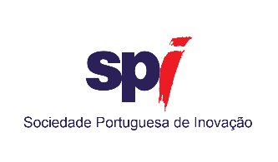

The Library and OTIC, although provided for in the IPVC Statutes as functional units, have not yet been constituted as such.
There is no data on unemployment rates for the courses of Visual Arts and Artistic Technologies, Computer Networks and Systems Engineering, Geoinformatics and Environmental Engineering, Mechatronic Engineering and Business Organization and management . Data on unemployment rates refer to the percentage of graduates from courses who, in 2018, were registered as unemployed at the Institute of Employment and Vocational Training. To calculate this percentage, all students who have graduated from the courses between the academic years 2013/14 and 2016/17 were taken into account.
In addition to the staff map, a number of services are also provided by companies or individual service providers.

